**1- using volatile vs AtomicInteger in java concurrency**

**Volatile  :  is generally used to solve the visibility problem**

Volatile keyword is **used to modify the value of a variable by different threads**. It is also used to make classes thread safe. It means that multiple threads can use a method and instance of the classes at the same time without any problem. The volatile keyword can be used either with primitive type or objects.

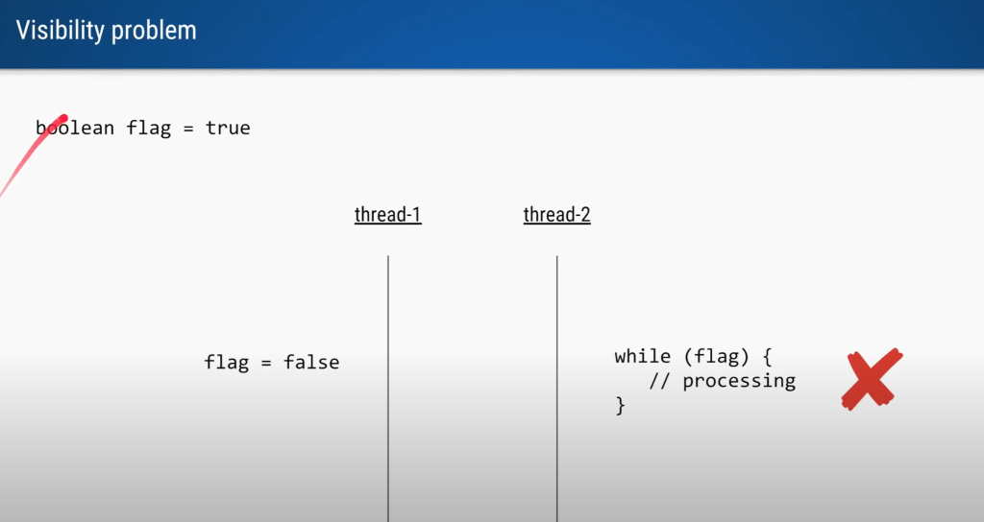

Let say we have variable flag = true

And thread2  doing processing it and thread 1 will change flag value to false but this is not

Visible or updated in thread 2

**Cpu cache structured**

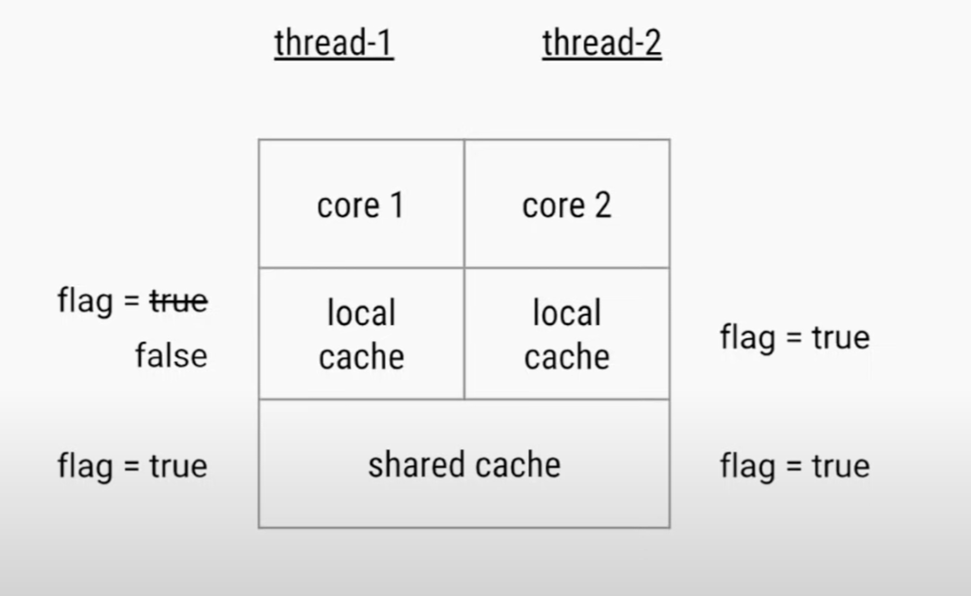

 Cpu with two core where thread1 and thread2 running resp. Each of these core will

Have local cache resp.

Since thread 1 update flag value  to false in its local cache which is not updated in thread2 local cache.

And that is why thread2 keep running in infinite while loop.

That problem we can resolve it just by adding keyword **volatile**

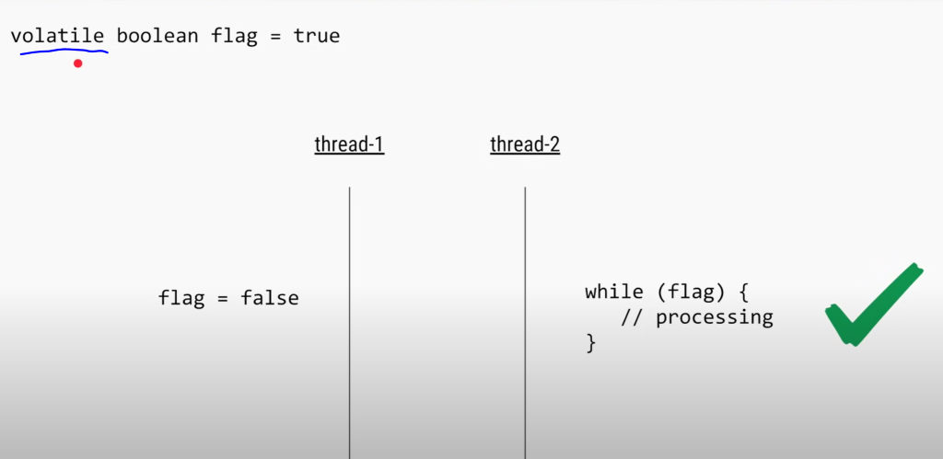

As soon as will update  value with keyword volatile this visibility of value will occur to thread2.

**The reason is visible** to thread 2 this time because any changes occur in local cache is push down to shared cache and refresh in the local cache of thread 2

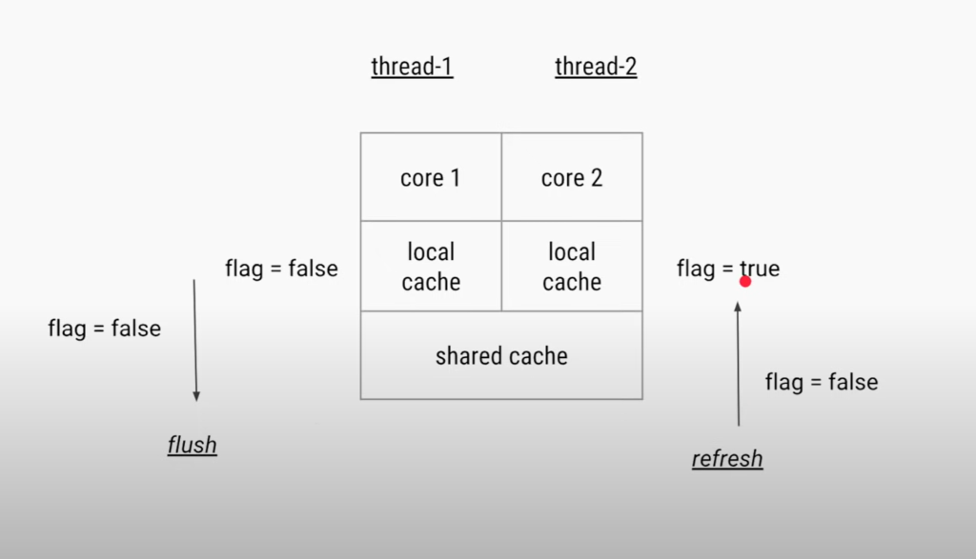

Example 2 :

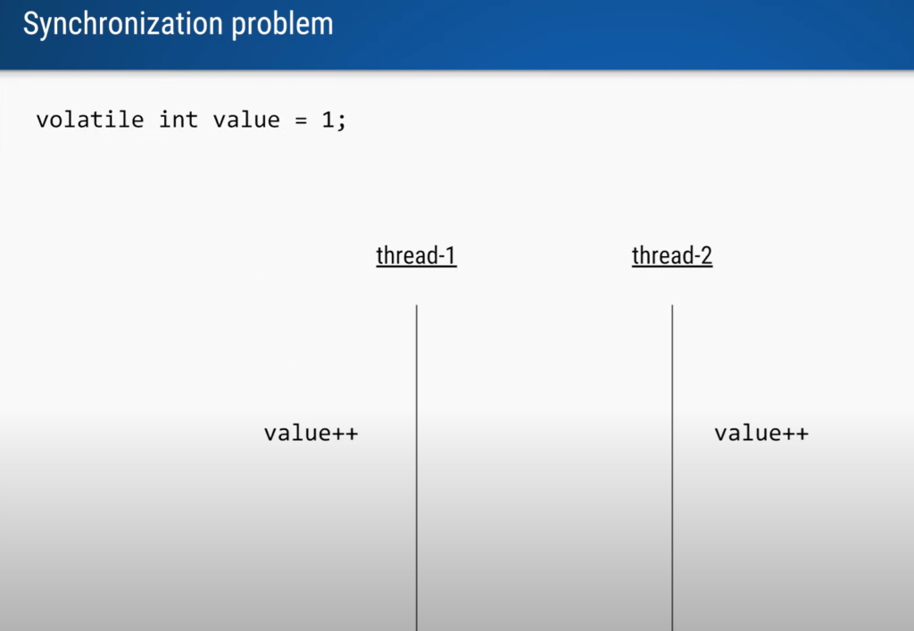

Even we add volatile keyword it will not work value will not increase as 2 and 3 by diff thread.

The reason is this is not a visibility problem . This is a synchronization problem.

It is two operation read and write and we don’t know scheduling of thread by CPU

So instead of value 2 and 3 that we are expecting we are getting 2 and 2

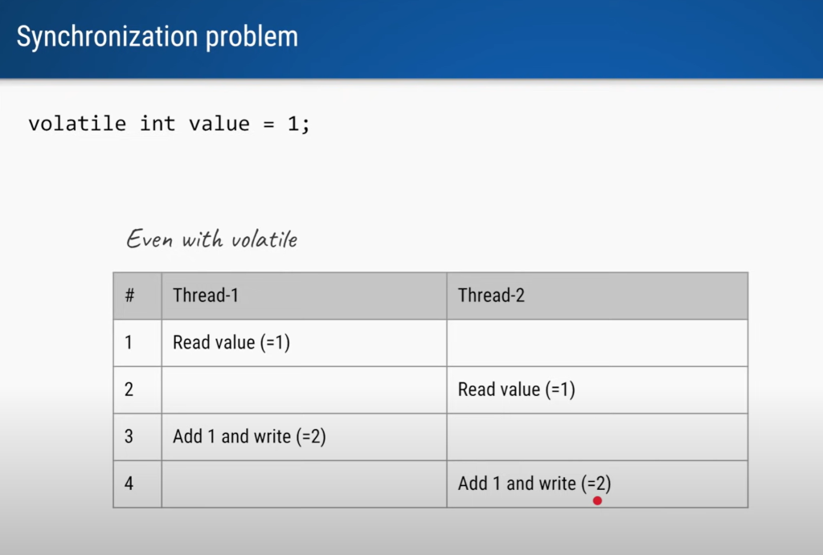

**To solve this problem**

**First way**

By using synchronized keyword  only one thread will execute at a time

**Second way** to solve this problem is to use AtomicInteger

We have single method which will do compound operation.

Even if we don’t use synchronized block it will make sure the read and write opearation will

Occur atomically

What is a compound operation?

Compound operations consist of **a read and write operation performed as one atomic operation**. An atomic operation is an operation which either completes entirely, or does not complete at all. Atomic operations cannot partially complete.



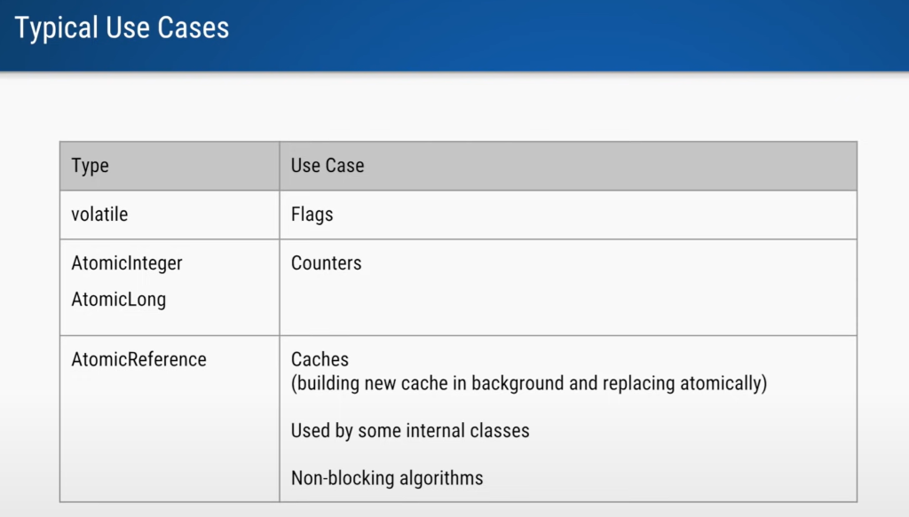

**2- ThreadLocal in java**

This class provides thread-local variables. These variables differ from their normal counterparts in that each thread that accesses one (via its get or set method) has its own, independently initialized copy of the variable. Basically, it is another way to **achieve thread safety** apart from writing immutable classes. Since the Object is no more shared there is no requirement for Synchronization which can improve the scalability and performance of the application. ThreadLocal provides thread restriction which is an extension of a local variable. ThreadLocal is visible only in a single thread. No two threads can see each other’s thread-local variable. These variables are generally private static fields in classes and maintain their state inside the thread.

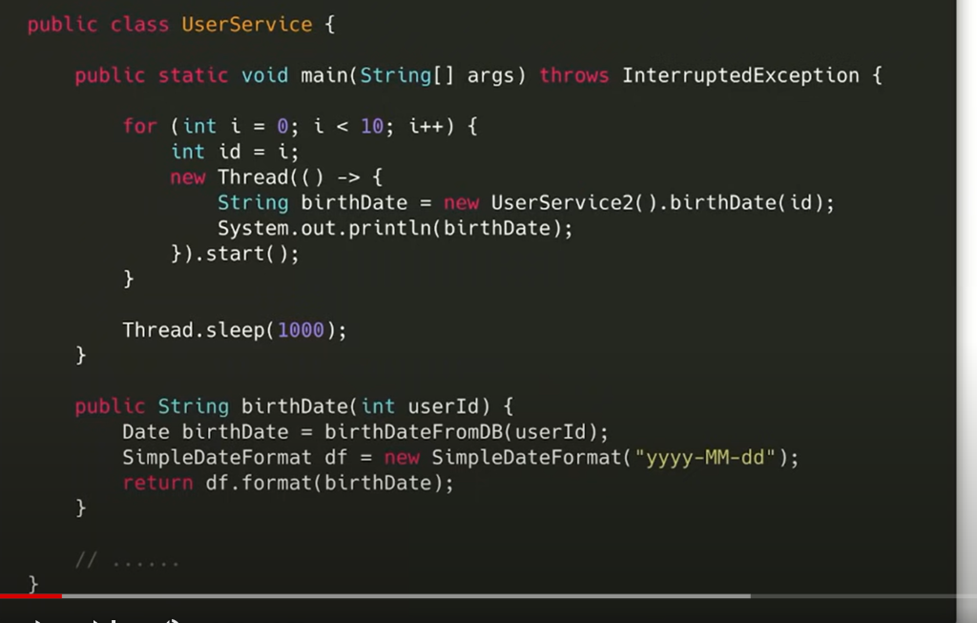

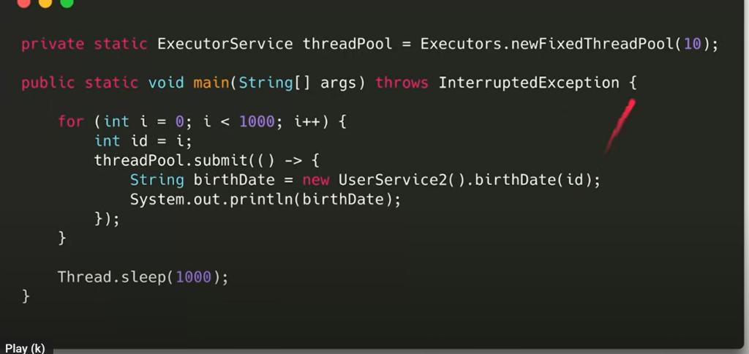

If we are making global SimpleDateFormat then it is not thread safe

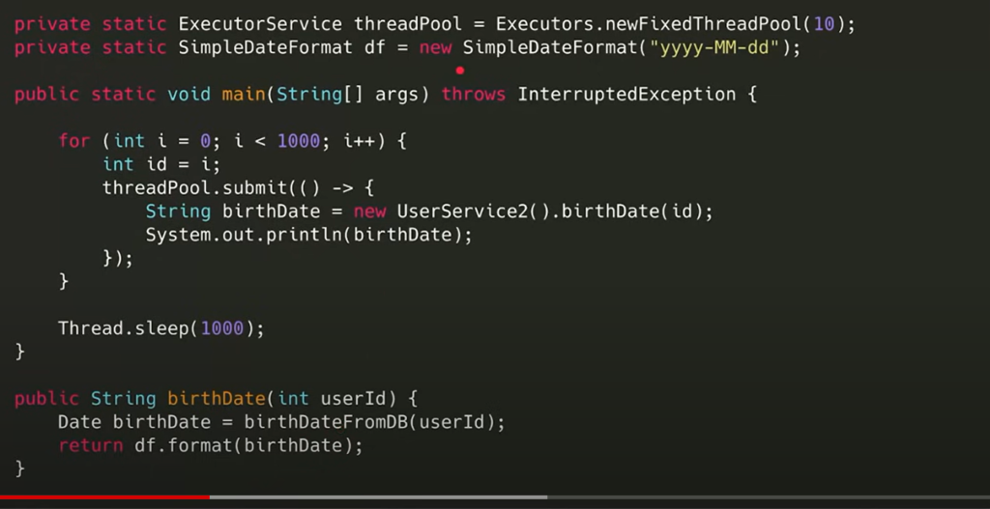

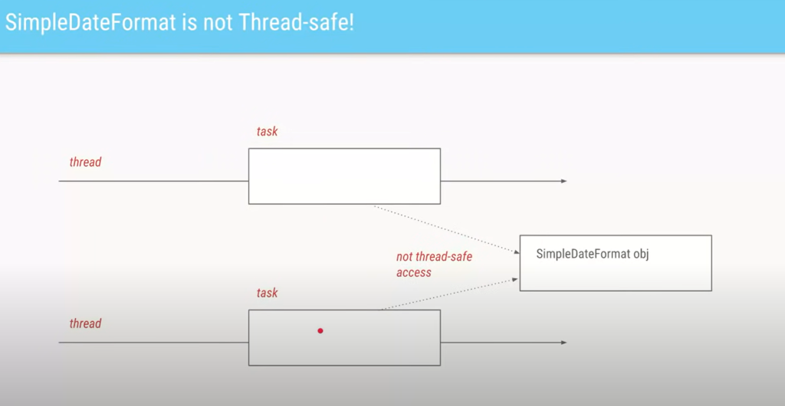

Since it is not thread safe one way to resolve this issue is to have lock but then perfoemance will become slow

Note :

We don’t want one object per task and global object we want one object for each thread

Since each of the thread access it own object so there will never be a synchronization issue

Requirement  : user info to get in multiple service

One way is to put user info into map and all other service will get it from map

NOte :

For multiple thread we required lock in case of map

If we are using threadlocal based on get it will return the user that is no synchronization is required

There is no synchronization here and we do not require to keep pass user from one service to another

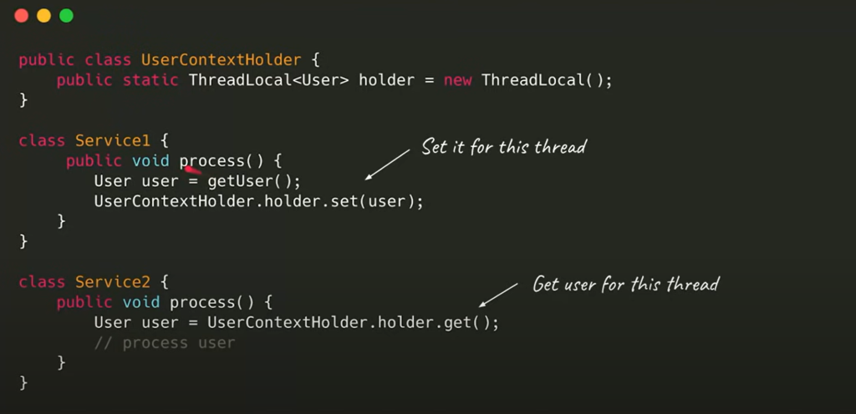

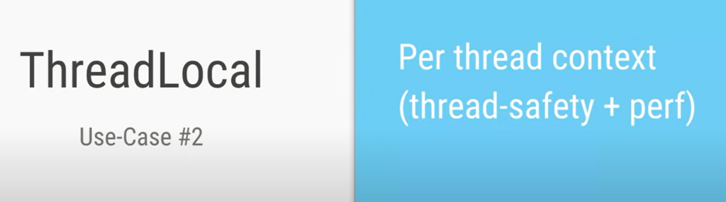

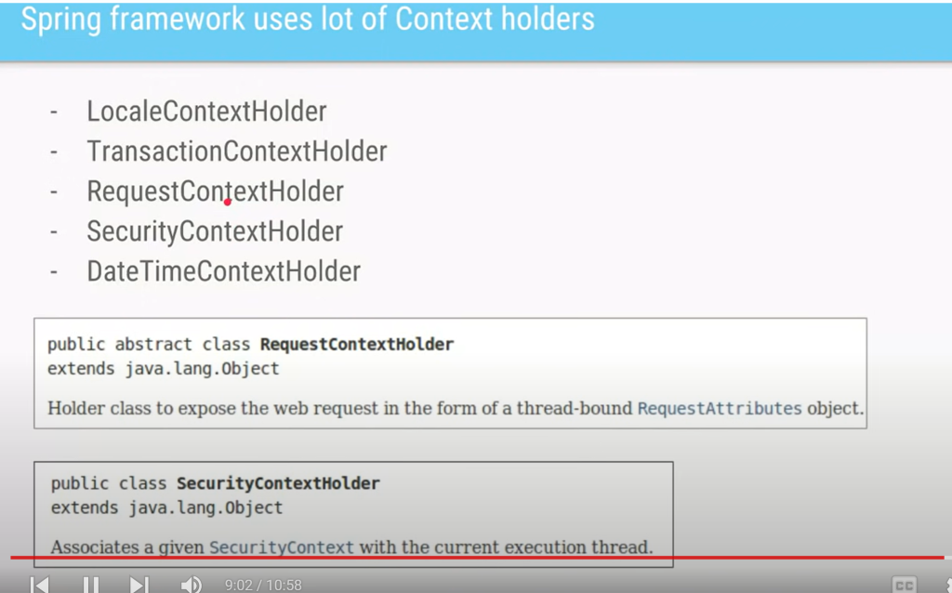

Once processing is done we need to remove the service

**3- Concurrency vs Parallelism**

**Concurrency is dealing with lot of thing happening at once and parallelism is doing lot of thing happening at once**

**Concurrency** is when two or more tasks can start, run, and complete in overlapping time **periods**. It doesn't necessarily mean they'll ever both be running **at the same instant**. For example, *multitasking* on a single-core machine.

**Parallelism** is when tasks *literally* run at the same time, e.g., on a multicore processor.

* Concurrency: A condition that exists when at least two threads are making progress. A more generalized form of parallelism that can include time-slicing as a form of virtual parallelism.
* Parallelism: A condition that arises when at least two threads are executing simultaneously.

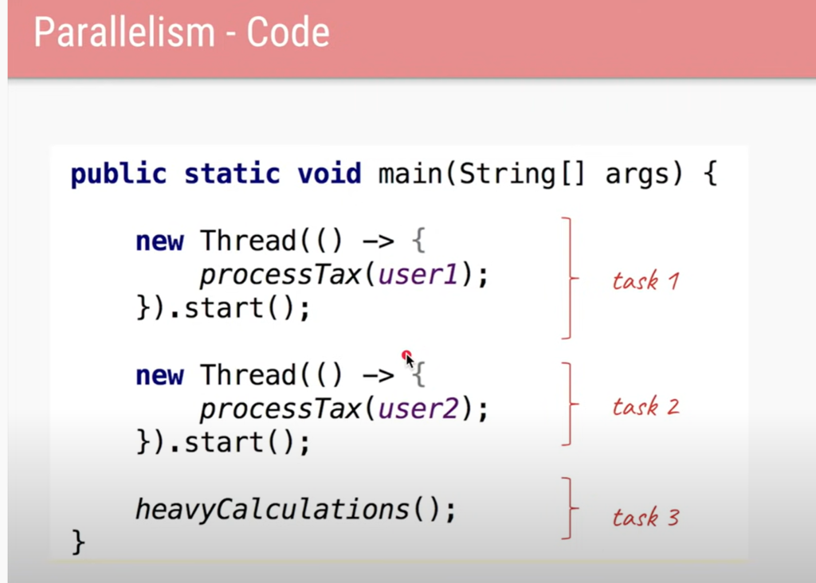

 in  os there is a component called scheduler which is responsible to schedule the thread

Since none of the task are dependent on each other so all the three task run parallel in each separate core

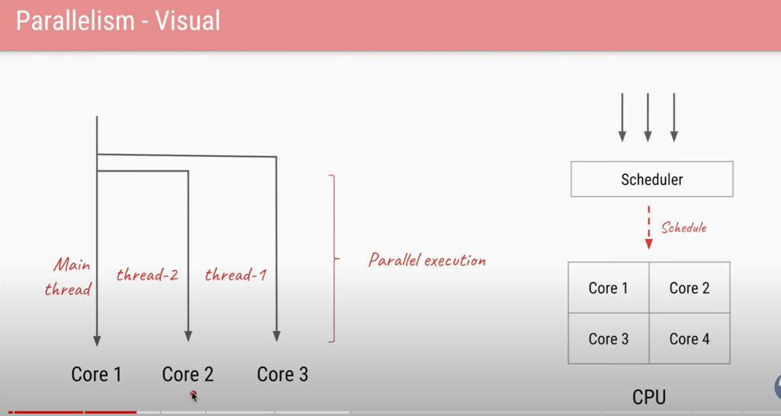



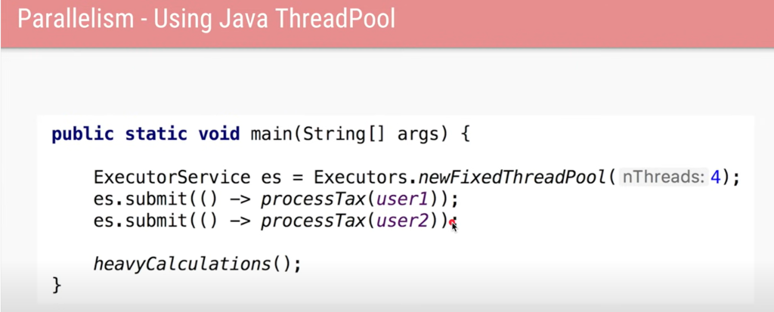

Concurrency code

Assume only one core is there in cpu

Note :

If available ticket is one then this is incorrect program. Time will be given by scheduler  if one core is there.

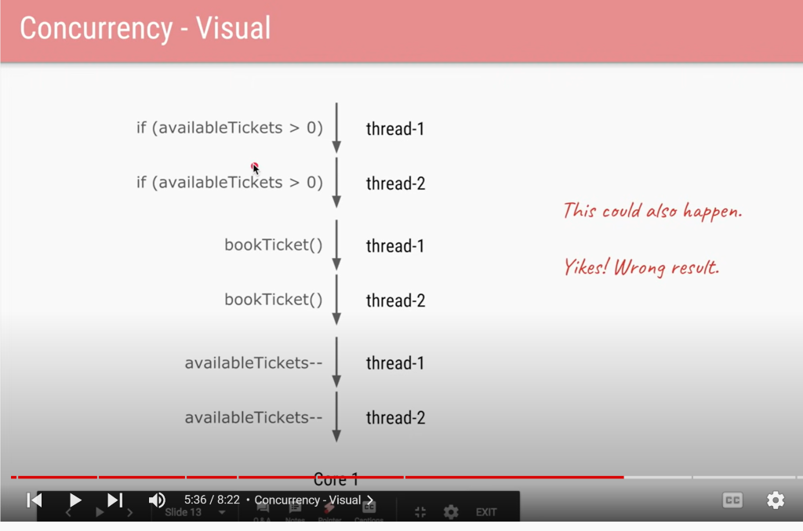

This also can happen in multiple cores

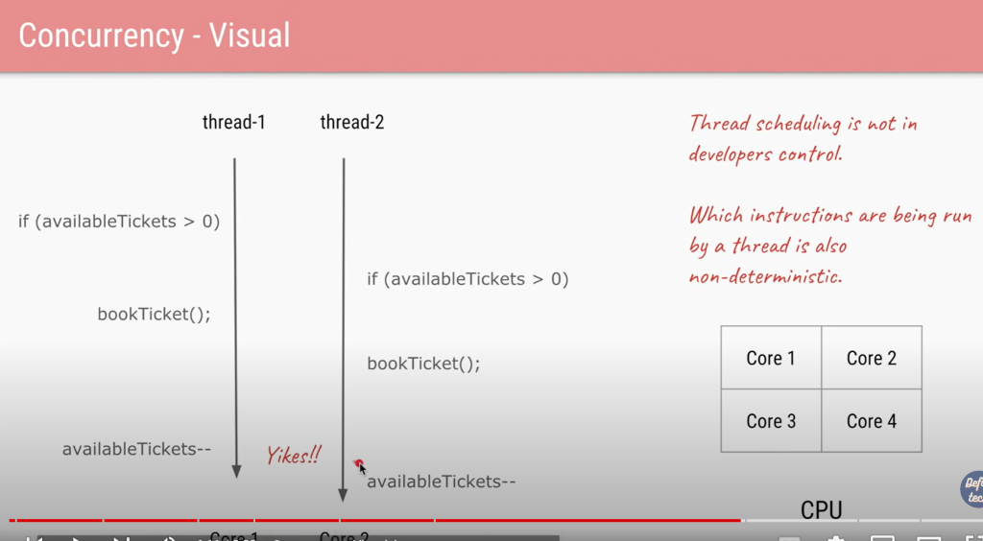

This problem can be fixed by lock

Two thread coordinating with each other using a single lock

In java we have lot of tools to deal with concurrency

**4- Java Memory model**

Here we load a twice

And these are the changes can be done by cpu, compiler or jvm to get more performance.

**While cores actually process tasks, a CPU is responsible for controlling the cores, as well as interfacing data from other computer system components to them**

Register is memory area which is very small

Field visibility issue

Java provide solution for this

Java memory model rule have to be implemented by all the JVM

Happens before relationship  :

**Before write to x and after reading to x it will be visible**

**Happens-before relationship**

Java defines a happens-before relationship as follows.

*Two actions can be ordered by a*happens-before*relationship. If one action*happens-before*another, then the first is visible to and ordered before the second.*

According to this, if there is a happens-before relationship between a write and read operation, the results of a write by one thread are guaranteed to be visible to a read by another thread. Therefore, we will be able to maintain the memory consistency if we are able to have the happens-before relationship between our actions.

Note :

This is also applicable to other

Note :

Volatile is not there

Note :

Synchronized should be apply on same object

Everything in synchronized block

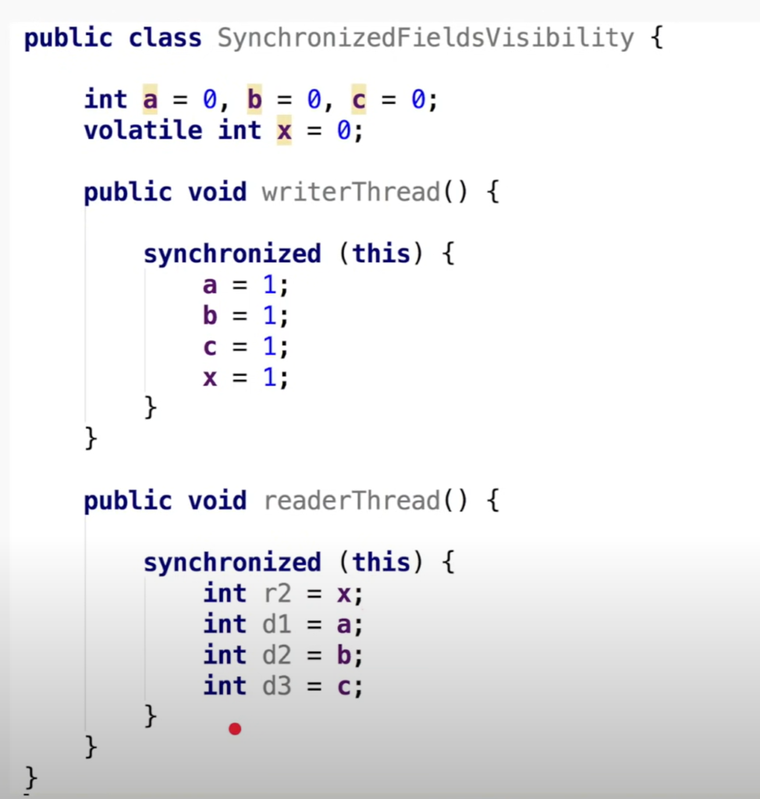

Similarly we can use lock operation

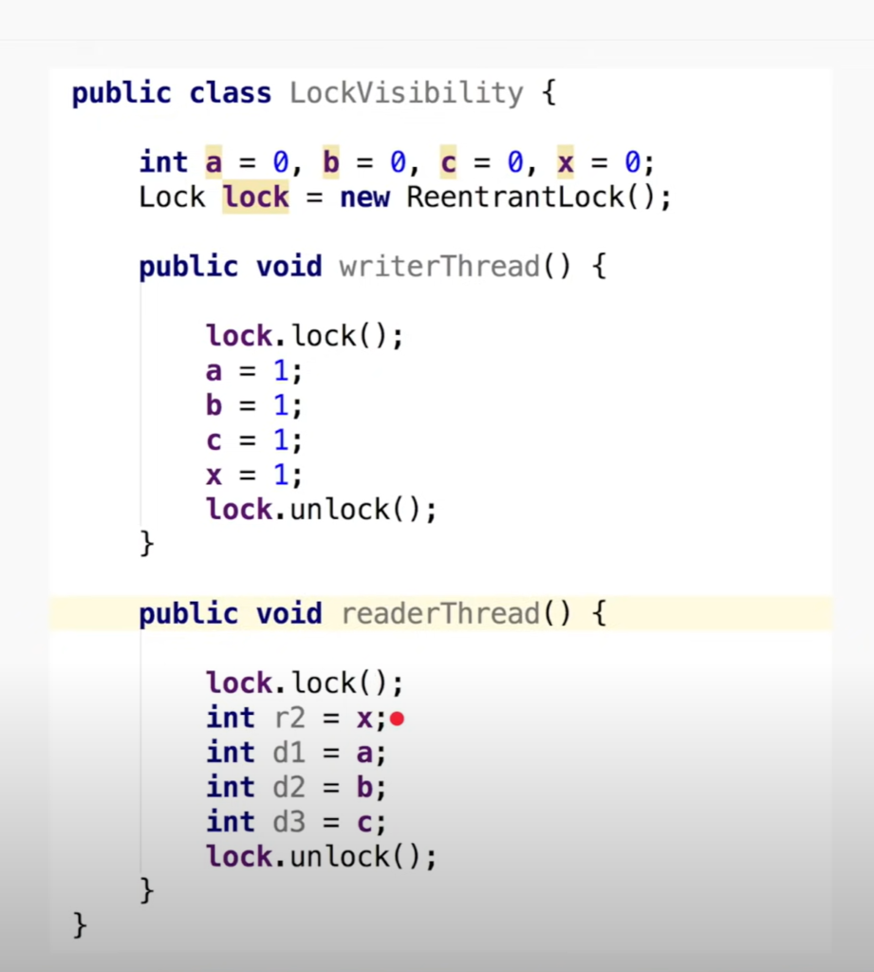

**5- Java Executor Service part 1**

Java Thread pool represents **a group of worker threads that are waiting for the job and reused many times**. In the case of a thread pool, a group of fixed-size threads is created. A thread from the thread pool is pulled out and assigned a job by the service provider.

Creating a thread is expensive operation

Note

The task which we submit to thread pool internally it using blocking queue and maintain all the task

Threadpool uses blocking queue which is thread safe.

Ideal pool size same number of thread as cpu cores

Code for this

**6- Java Executor Service part 2**

**Fixed Thread pool** :- all the task will be submit to blocking queue

2-**cached threadPool**

What is cached thread pool?

The cached thread pool configuration **caches the threads (hence the name) for a short amount of time to reuse them for other tasks**. As a result, it works best when we're dealing with a reasonable number of short-lived tasks. The key here is “reasonable” and “short-lived

Here we do not have a fixed number of thread

3-**scheduled threadPool**

What is scheduled thread pool?

ScheduledThreadPoolExecutor class in Java is **a subclass of ThreadPoolExecutor class defined in java.** **util.** **concurrent package**. As it is clear from its name that this class is useful when we want to schedule tasks to run repeatedly or to run after a given delay for some future time.

Want to scheduled a task after a certain delay

Like want to check security check , login check

4- **single thread executors**

Only one thread will be there and if the thread is killed new thread will be create and task will execute

This we will use when we are sure that task1 will execute before task2 and so on. Since only one thread and task run sequentially

**7- Java Executor Service part 3**

What is keep alive time in thread pool?

keepAliveTime - when the number of threads is greater than the core, this is **the maximum time that excess idle threads will wait for new tasks before terminating**. unit - the time unit for the keepAliveTime argument. workQueue - the queue to use for holding tasks before the are executed.

Number of thread slowly be deleted from thread pool and it will never go below core pool size.

**Types of queue**

Note : LinkedBlockingQueue keep on  increasing in size

ArrayBlockingQueue is bounded queue until it is full

In this case thread pool will reject task if new task is submitted and all the thread is busy and the thread will also

Reject the task in certain way.

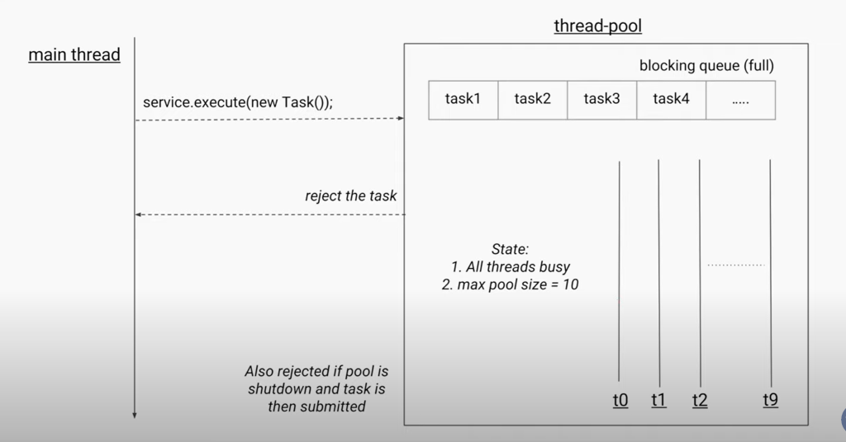

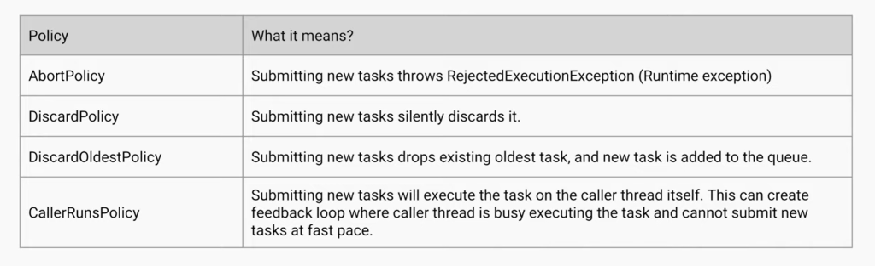

Let see rejected exception in terms of code

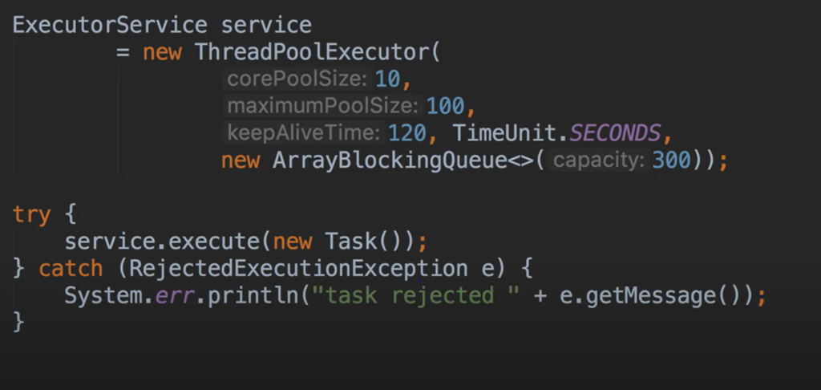

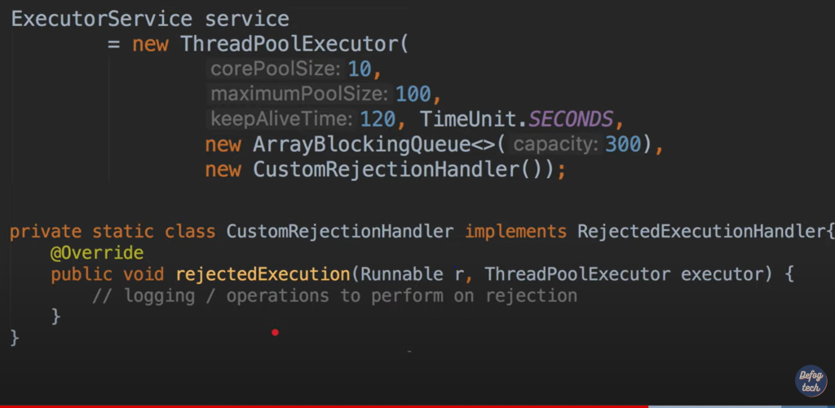

Shutdown a thread pool

After shutdown if we try to execute task will get exception

Shutdownnow :--- will not execute task that are queued

**8- Java Executor Service part 4**

What if task want to return a value for this will implement callable interface

Service.execute :----will take runnable task

Service.submit :--- will take callable task

Now we need to accept the integer value in some variable which is return by task and that variable us future

**Future.get()**will give actual integer result of that callable task

Future is the placeholder for the value which will be arrived sometimes in future

Callable with future use for to return value from task do some unrelated operation and get  value from future.get

A Future **represents the result of an asynchronous computation**. Methods are provided to check if the computation is complete, to wait for its completion, and to retrieve the result of the computation.

Main thread will go in blocked state if task 1 didn’t get value

One way to overcome this problem is to use timeout

If task is already started then cancel has no effect

**9- Java Asynchronous programming**

What if task want to return a value for this will implement callable interface

                                          10 : Lock Condition  in java

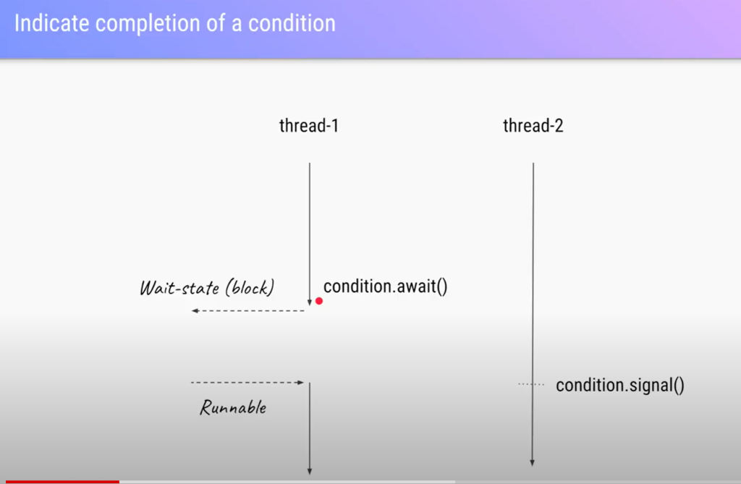

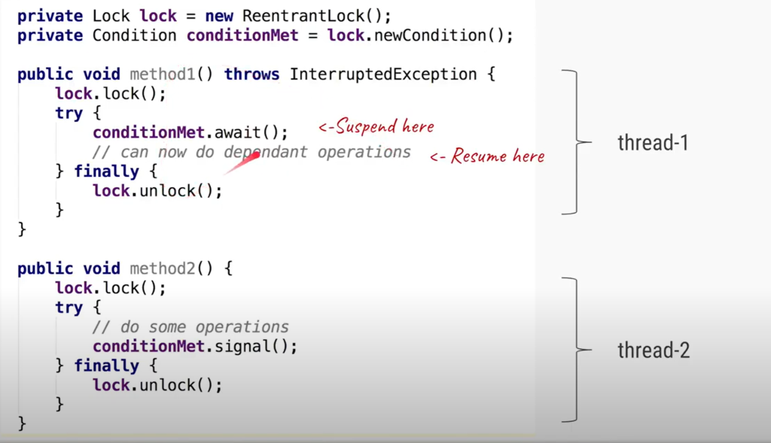

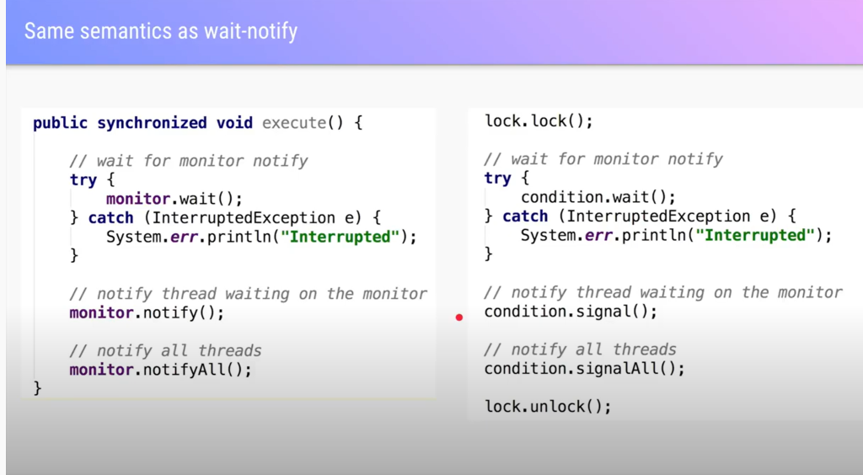

Multiple thread waiting  on same condition

11—introduction to completableFuture

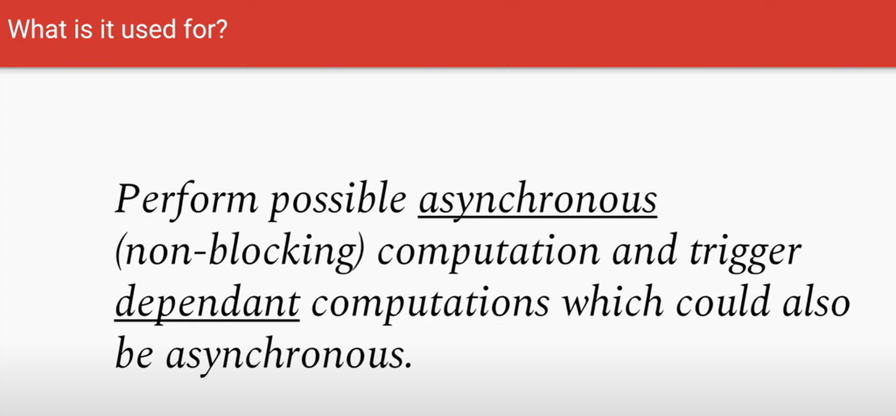

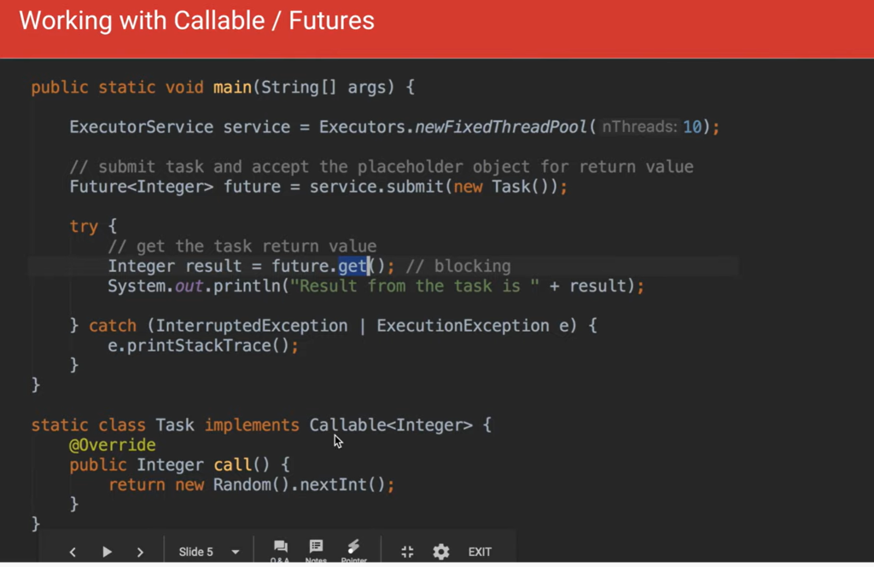

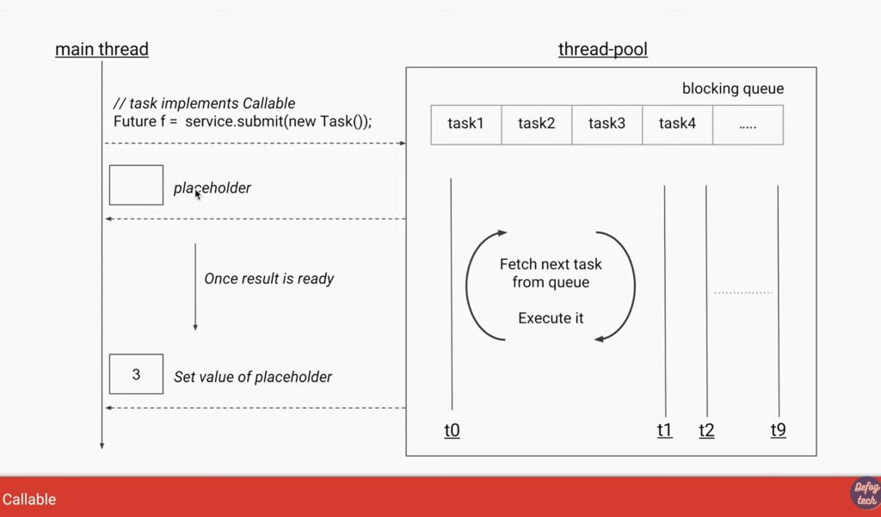

Main thread blocked

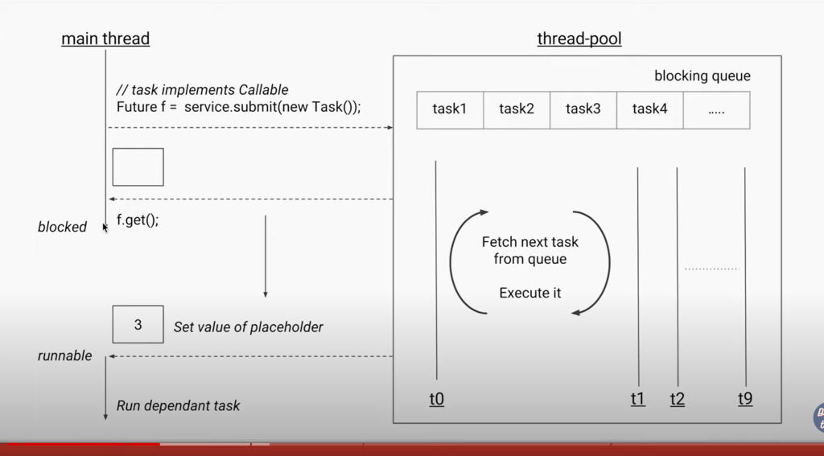

When multiple task need to submit then problem is more cumbersome

More example

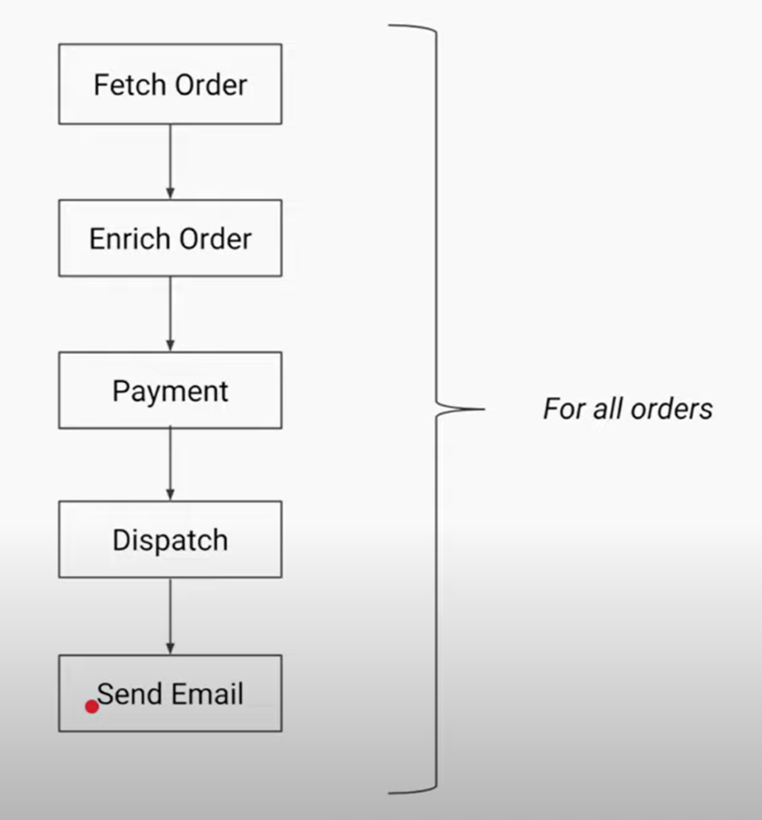

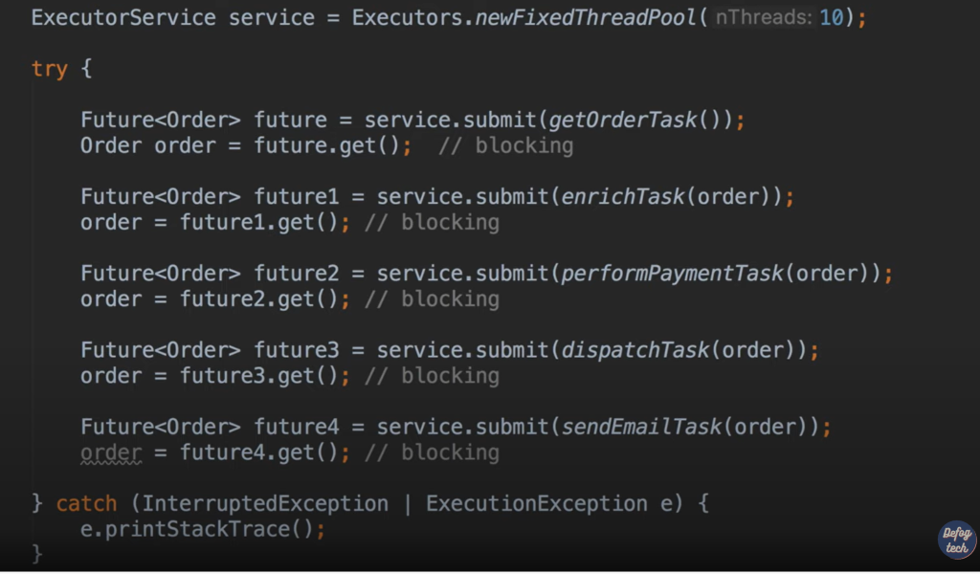

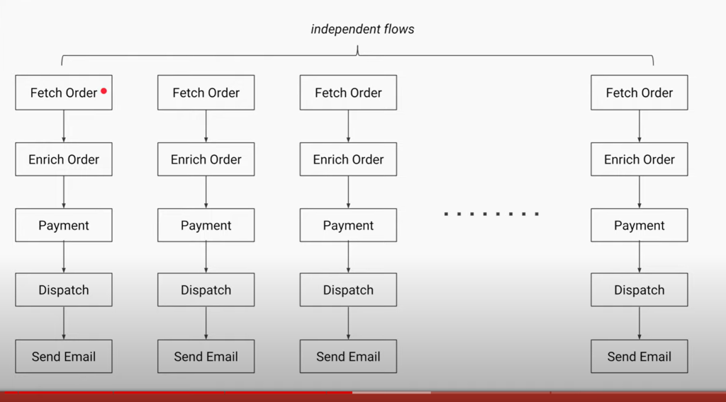

Run task in diff threadpool

Note :

The main  thread will never get blocked and whole thing internally will take care by thread pool.

Internally it uses fork join pool

The advantage of the asynchronous implementation based on the CompletableFuture class is **shorter execution time (because some tasks run in parallel) and more fluent code**.

**Synchronous Callback :**Any process having multiple tasks where the tasks must be executed in sequence and doesn’t occupy much time should use synchronous Callbacks.   
For example : You’re in a movie queue for ticket you can’t get one until everyone in front of you gets one.

**Asynchronous Callback :** When the tasks are not dependent on each other and may take some time for execution we should use Asynchronous callbacks.   
For example : When you order your food other people can also order their food in the restaurant. They don’t have to wait for your order to finish, If you’re downloading a song from internet, Getting an API response.

12-  what are coroutines (aka java fibres in project loom)

Use case :

from external website using http get 100000  product and update price and save in d/b

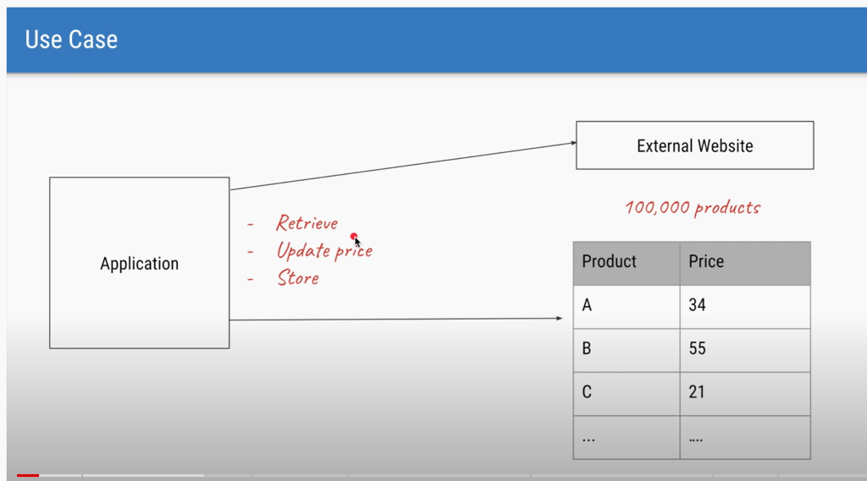

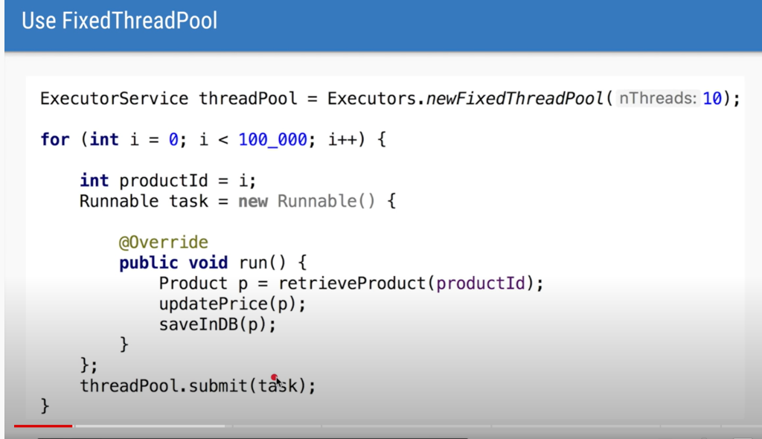

Solution : cached thread pool

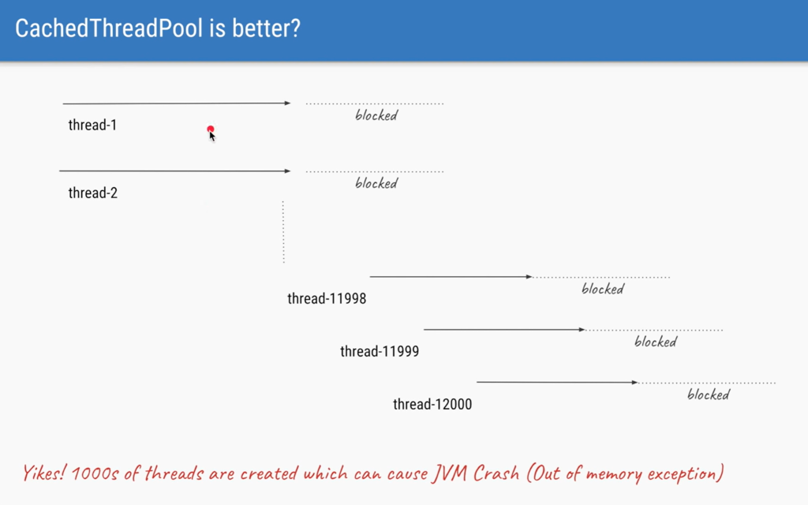

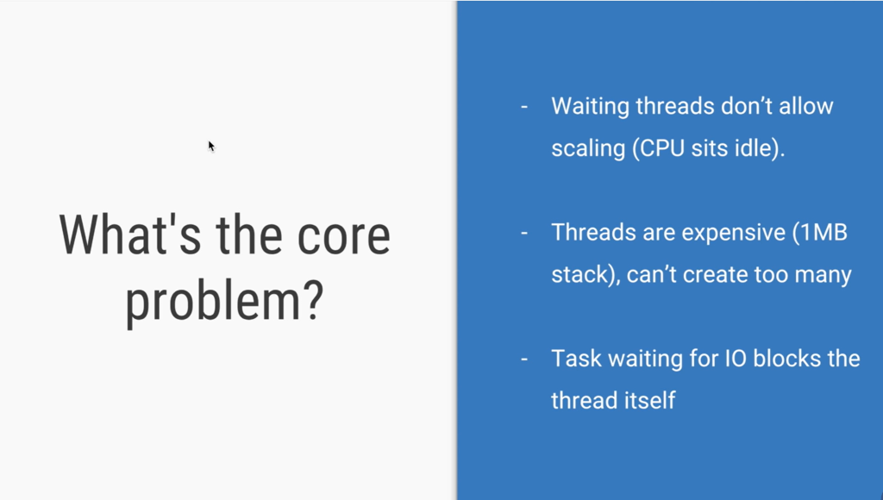

Solution : reactive programming

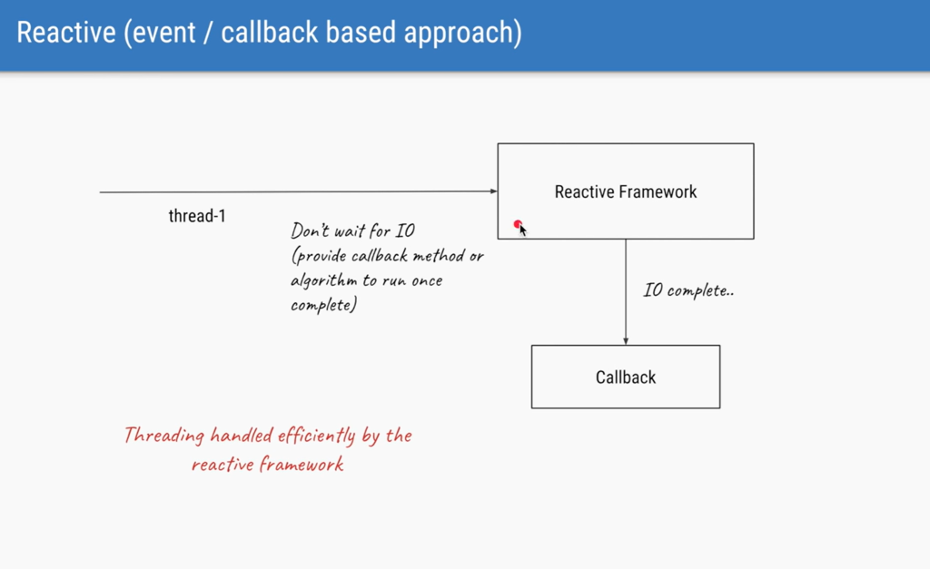

Mount task on free thread

If there is any blocking operation unmount the thread and mojnt in some other thread

                                                13 – java reentrant lock

Allow one thread to book a seat at a time otherwise it will be a problem

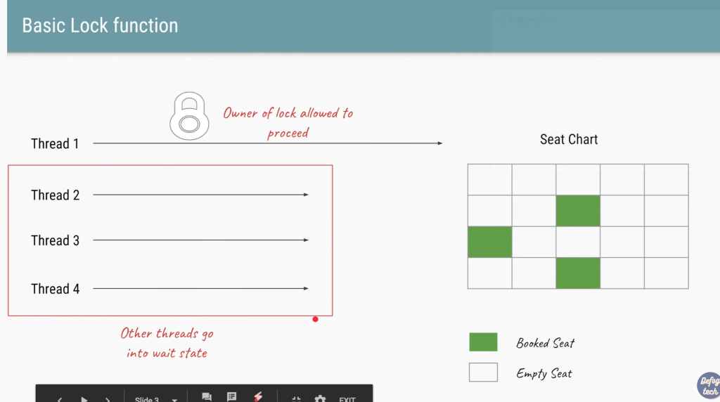

Lock allow to restrict the resources to the shared resource such that only one thread can access the resource

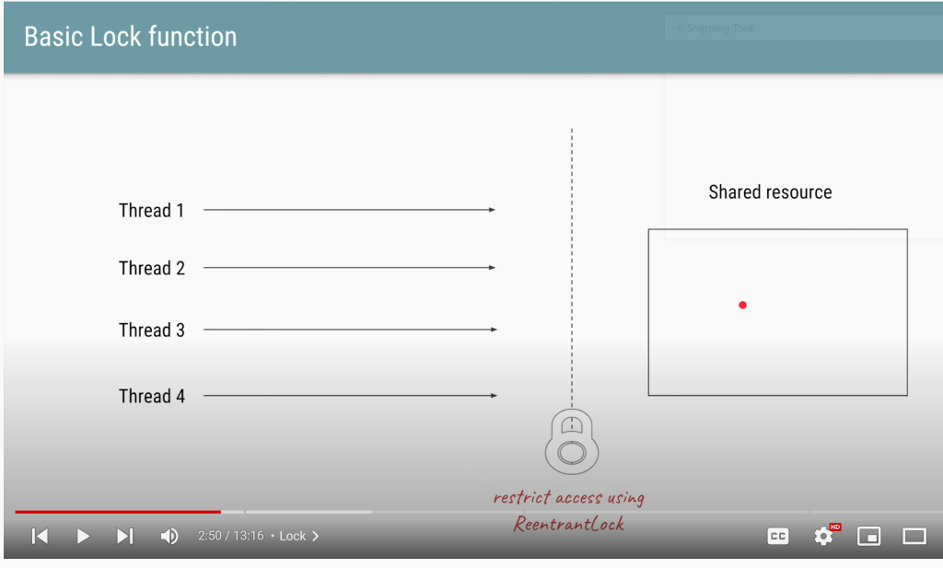

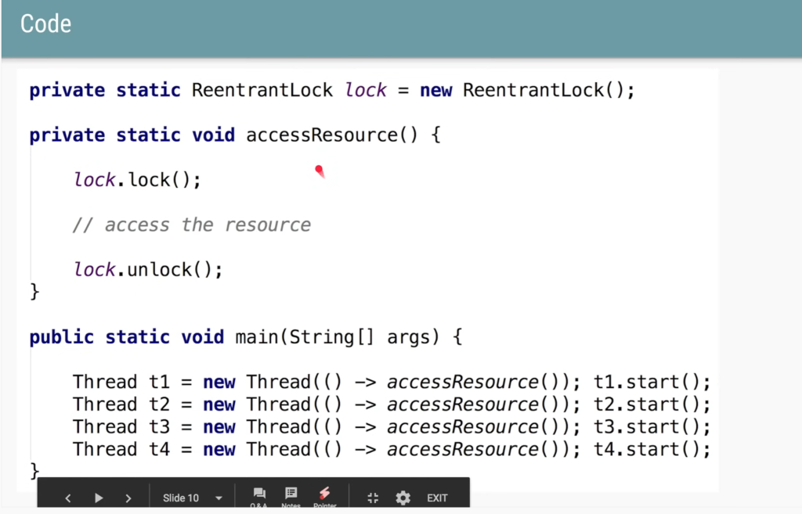

Synchronized is implicit and lock is explicit because we have to create variable for it

**Note**

In case of lock, we can acquire lock in one method and can release lock in another method

It is always advisable to unlock in finally , otherwise exception can come and it will never execute unlock  statement

In fairness : first come and first serve

Try lock will not block let do something else

And also we can do try lock with timeout

These method are usually use for debugging

**Lock is an interface.** **It defines a set of methods that all locks should have.** **ReentrantLock is a concrete class that implements the Lock interface**. It implements all the methods defined in Lock , plus much more

**What are Reentrant Locks?**

* ReentrantLock in Java is added on java.util.concurrent package in Java 1.5 along with other concurrent utilities like CountDownLatch, Executors and CyclicBarrier.
* ReentrantLock is a concrete implementation of Lock interface provided in Java concurrency package from Java 1.5 onwards.
* Reentrant Locks are provided in Java to provide synchronization with greater flexibility.
* The code which manipulates the shared resource is surrounded by calls to lock and unlock method. This gives a lock to the current working thread and blocks all other threads which are trying to take a lock on the shared resource.
* A ReentrantLock allow threads to enter into lock on a resource more than once. When the thread first enters into lock, a hold count is set to one. Before unlocking the thread can re-enter into lock again and every time hold count is incremented by one. For every unlock request, hold count is decremented by one and when hold count is 0, the resource is unlocked.
* Fairness parameter is provided while creating instance of ReentrantLock in constructor.
* ReentrantLock provides same visibility and ordering guarantee, provided by implicitly locking, which means, unlock() happens before another thread get lock().
* If you forget to call the unlock() method in the finally block, it will lead to bugs in the program. Make sure that the lock is released before the thread exits.
* The fairness parameter used to construct the lock object decreases the throughput of the program.

**Difference between ReentrantLock and synchronized keyword in Java**

* We can achieve thread synchronization in Java by using the ‘synchronized’ keyword. While it provides a certain basic synchronization, the synchronized keyword is quite rigid in its use. e.g, a thread can take a lock only once. Synchronized blocks don’t offer any mechanism of a waiting queue and after the exit of one thread, any thread can take the lock. This could lead to starvation of resources for some other thread for a very long period of time. ReentrantLock provides a method called lockInterruptibly(), which can be used to interrupt thread when it is waiting for lock. Similarly tryLock() with timeout can be used to timeout if lock is not available in certain time period.
* Fairness property provides lock to longest waiting thread, in case of contention. synchronized keyword doesn’t support fairness. Any thread can acquire lock once released, no preference can be specified. ReentrantLock fair by specifying fairness property, while creating instance of ReentrantLock.
* ReentrantLock provides convenient tryLock() method, which acquires lock only if its available or not held by any other thread. This reduce blocking of thread waiting for lock in Java application. This is not possible in case of synchronized keyword.
* ReentrantLock also provides convenient method to get List of all threads waiting for lock. We can create different conditions for Lock and different thread can await() for different conditions.
* Synchronization code is much cleaner and easy to maintain whereas with Lock we are forced to have try-finally block to make sure Lock is released even if some exception is thrown between lock() and unlock() method calls.
* synchronization blocks or methods can cover only one method whereas we can acquire the lock in one method and release it in another method with Lock API.

                                          14 -   Read write lock vs reentrant lock

Read write lock

All four thread trying to acquire the lock

This is slight inefficient since thread 2  also want to view seat and no update

More efficient

Readlock will be allow t1 and t2 at the same time

T2 AND T4  acquire lock and new thread coming continuously to  view but new Thread wll wait in queue since T5 is already waiting in queue to write.

                                                             15 – what are java interrupts

T1 :-- main Thread

Note : there is no cancel method on thread

It may or may not stop using interrupt

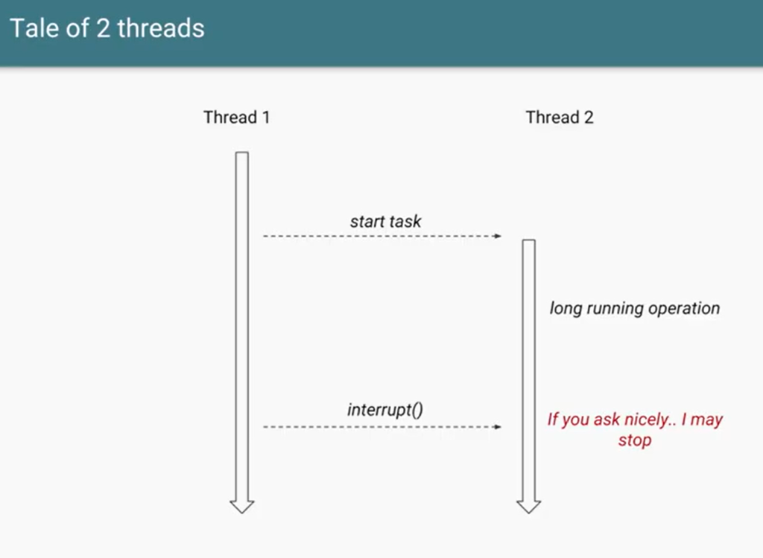

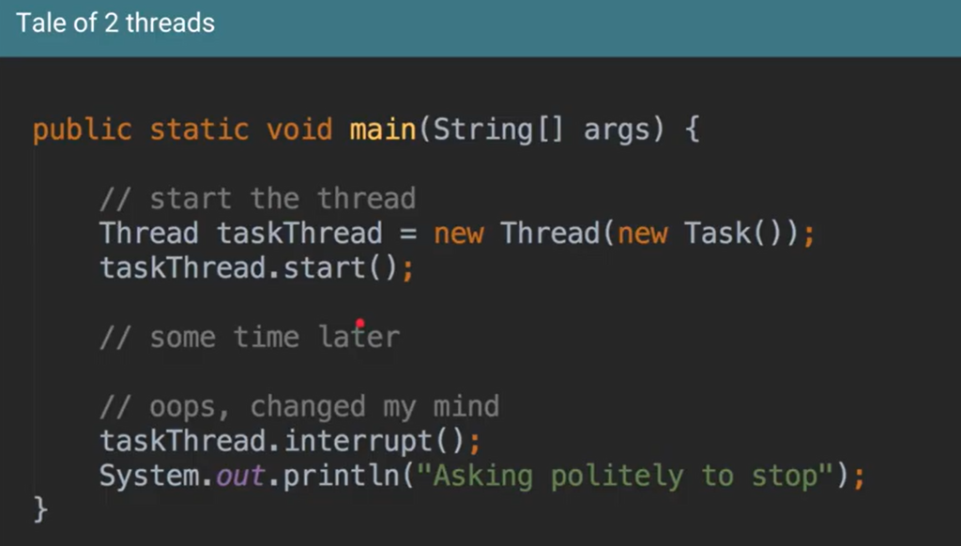

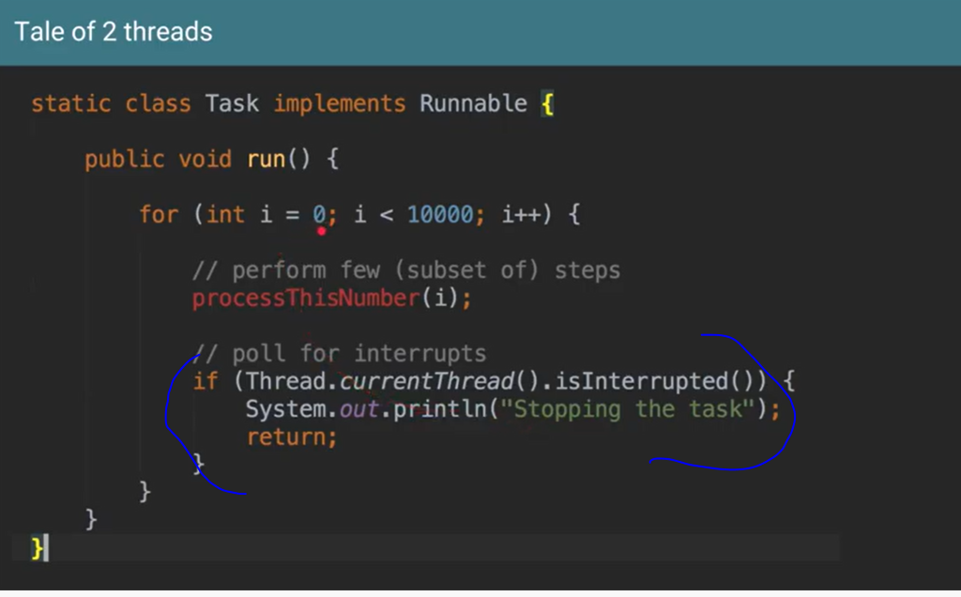



Reset the value to false

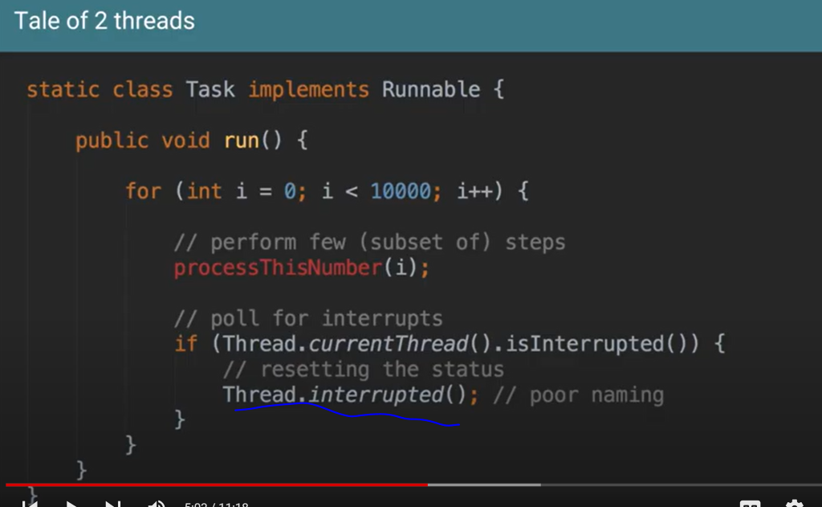

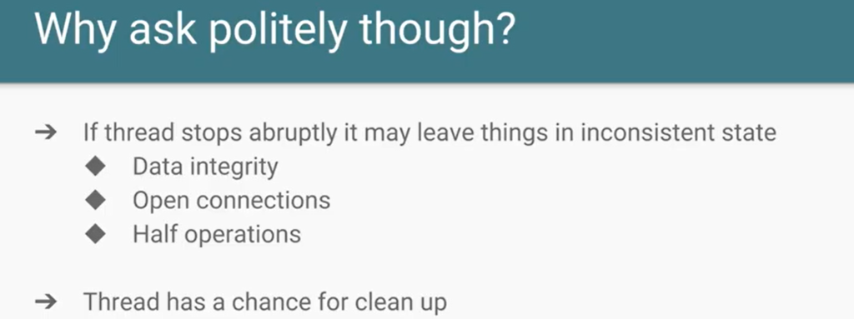



Runnable don’t allow to throw checkedException  while callable allow to throw checkedException

And InterruptedException is checked exception

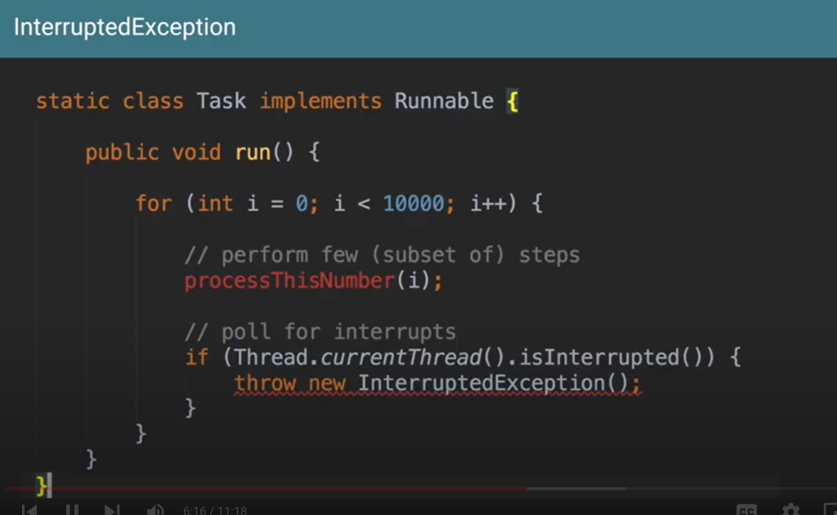

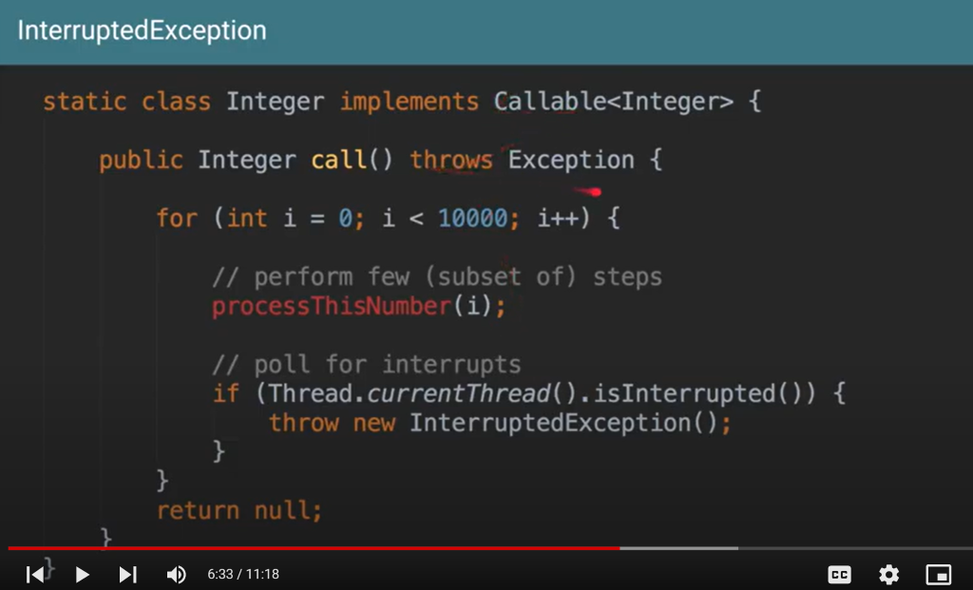

The main reason to throw interruptedException is to main thread know that I have stopped my current operation

InterruptedException

Featured snippet from the web

java.lang.InterruptedException. **Thrown when a thread is waiting, sleeping, or otherwise occupied, and the thread is interrupted, either before or during the activity**. Occasionally a method may wish to test whether the current thread has been interrupted, and if so, to immediately throw this exception.

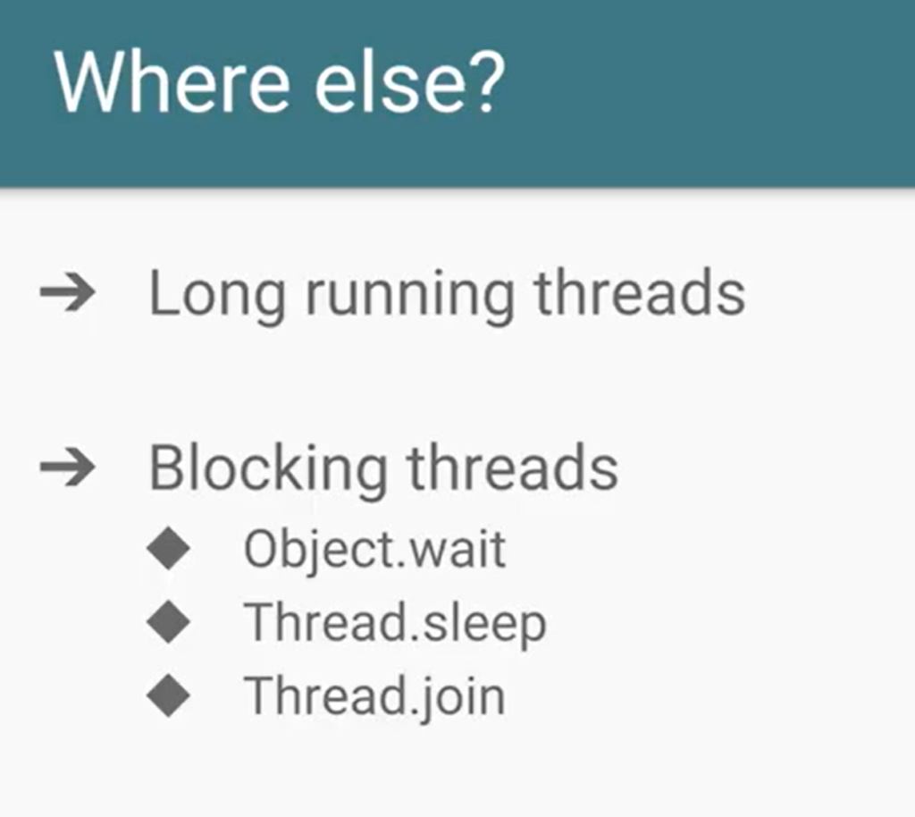

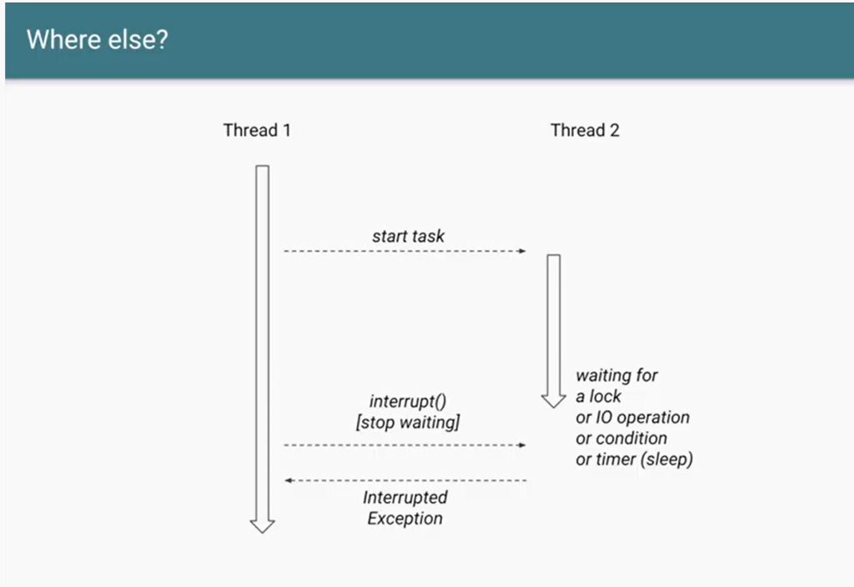

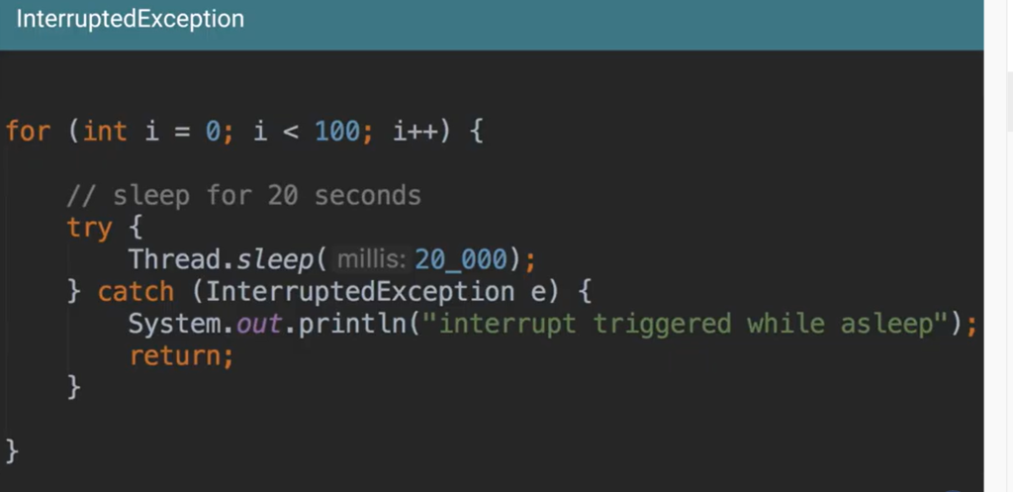

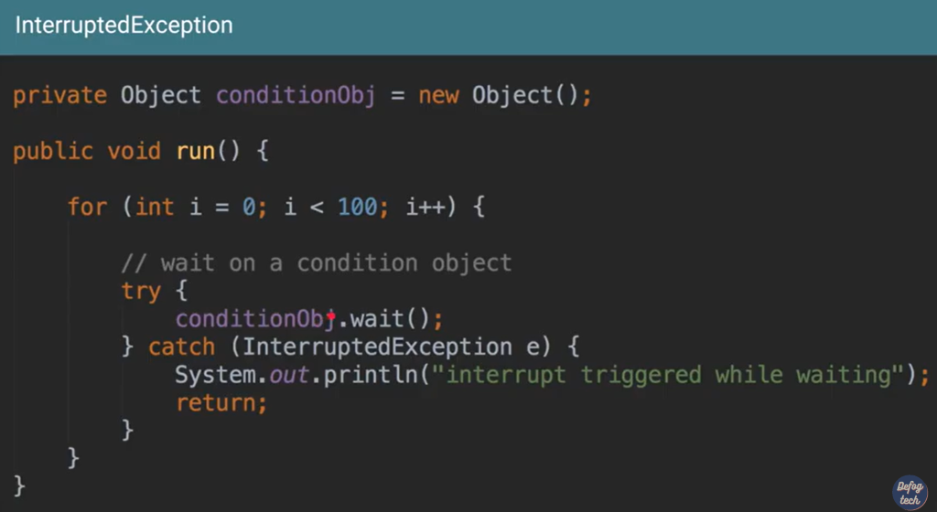

There are two check the interrupted status

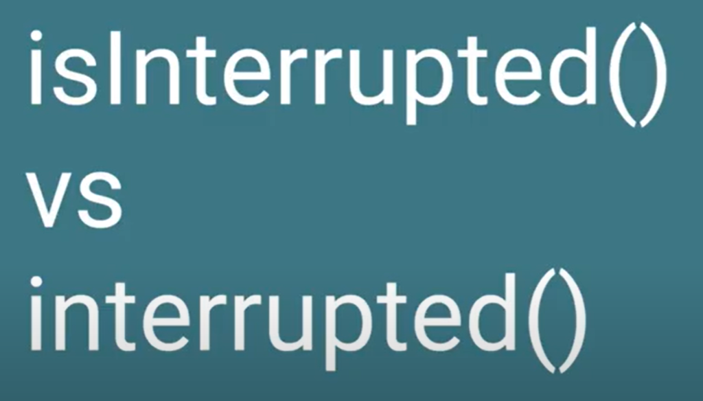

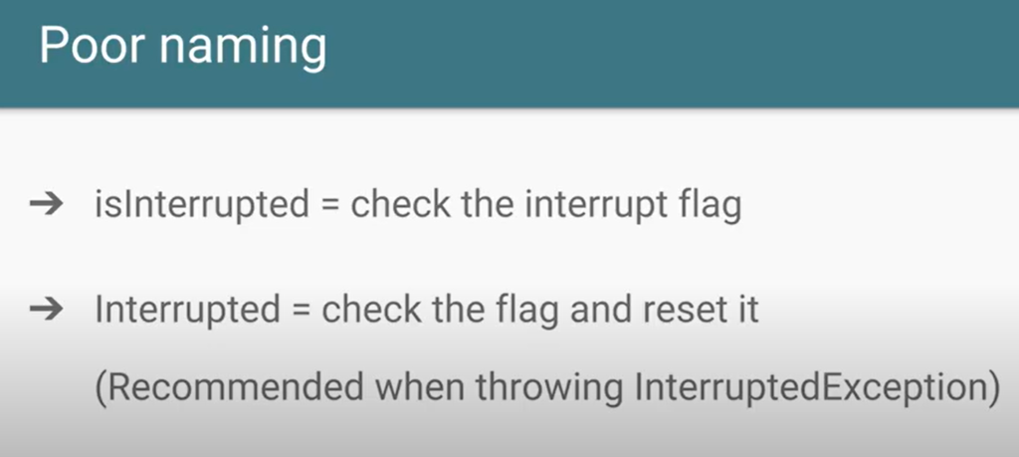

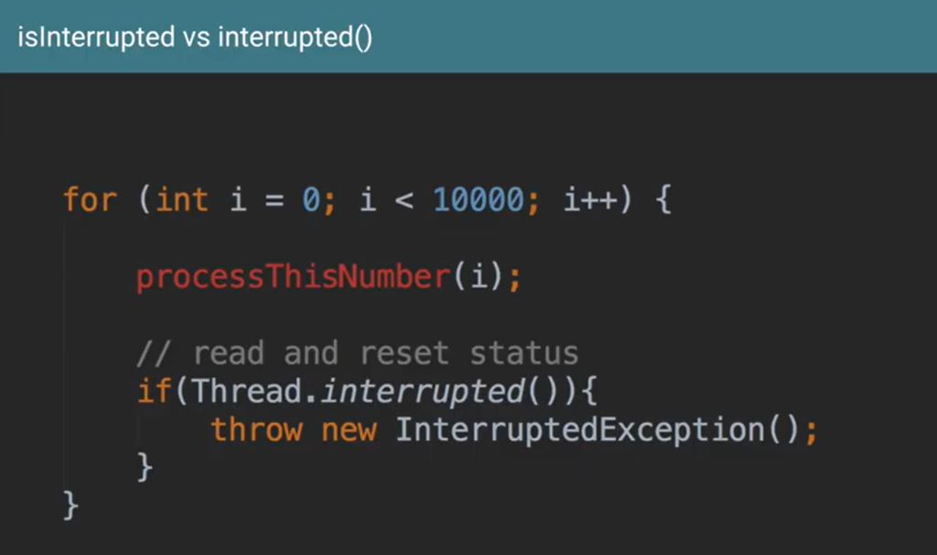

Interrupt is cooperative mechanism b/w  T1 to tell  T2 to stop it operation

16 – Semaphore in java concurrency

Use case :

Lets we have an application which connect to service which is slow and that is why we restrict the call from the application to the service. Let only three call are allowed at a time

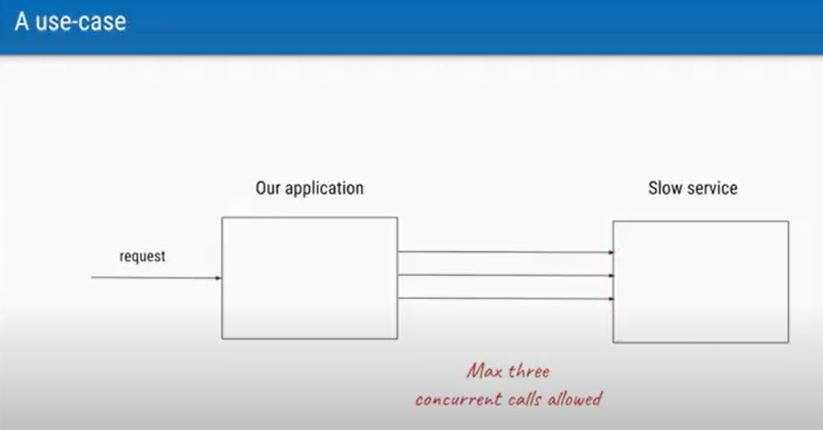

Let say we have 50 thread in our application

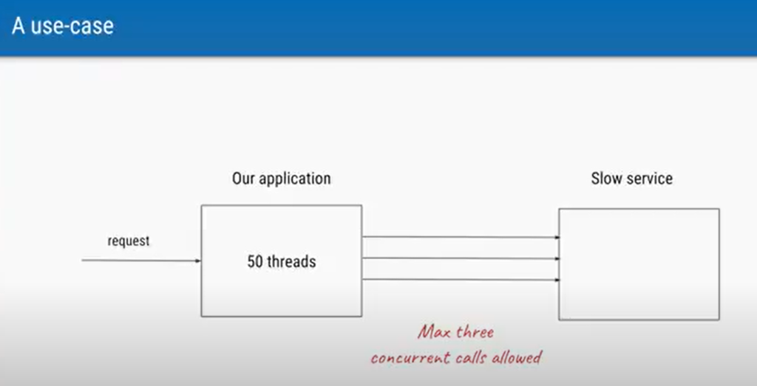

We are submitting 1000 task to threadpool service

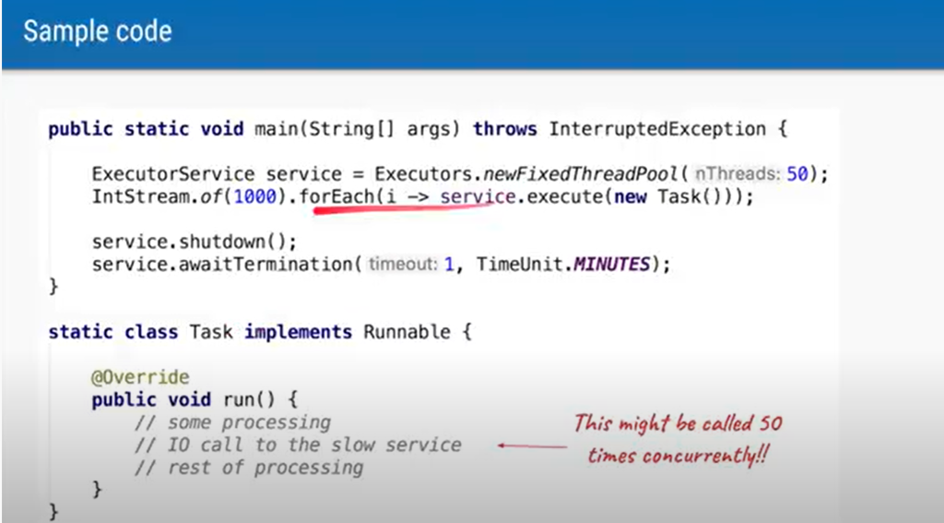

Since 50 thread are there so there is possibility more than one thread will run at a time so we want a mechanism only

Three thread will run at a time and that is where we use the concept of semaphore

Semaphore has three permit

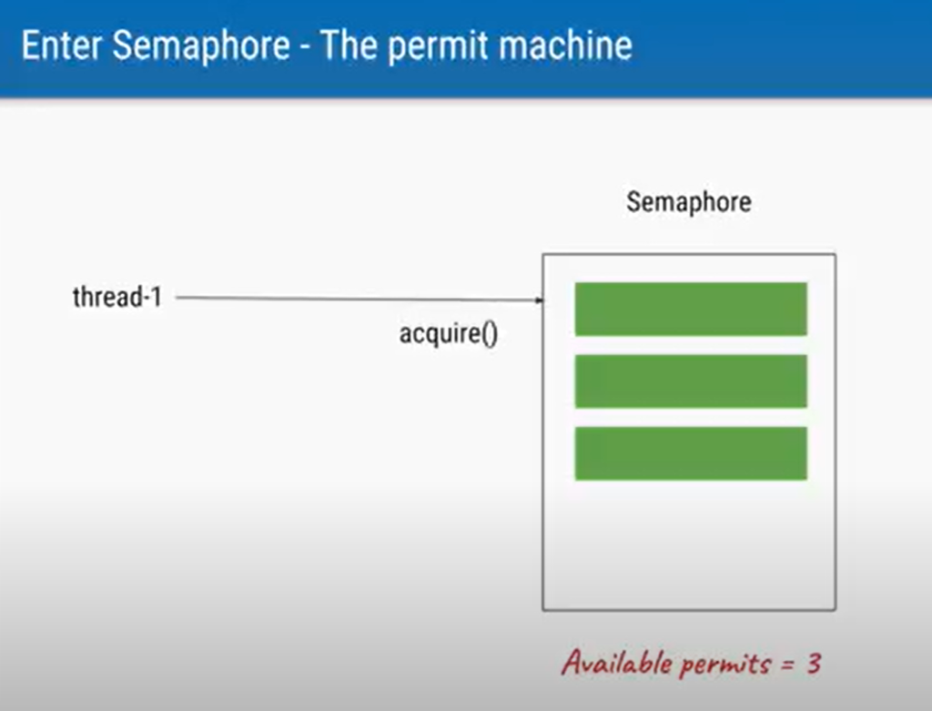

Since semaphore has three permit it will allow thread1 to access service

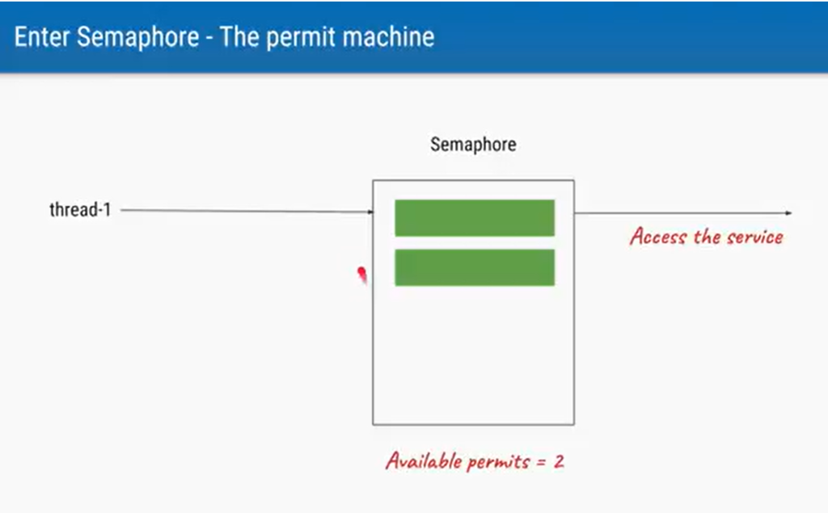

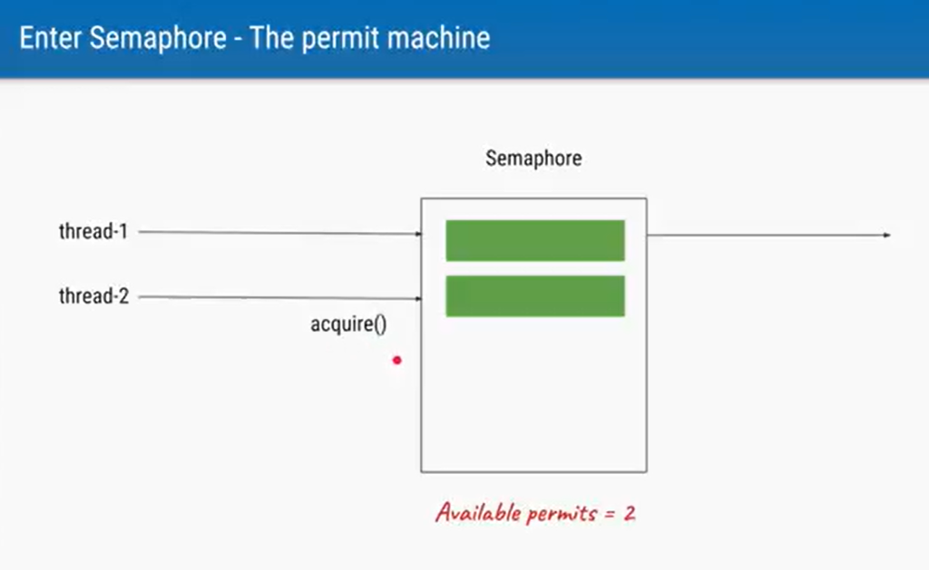

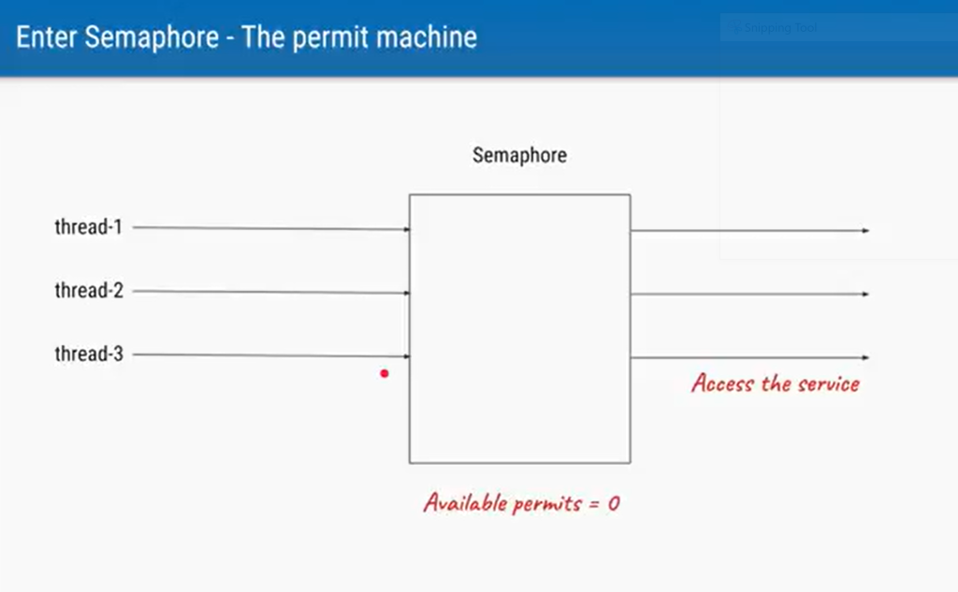

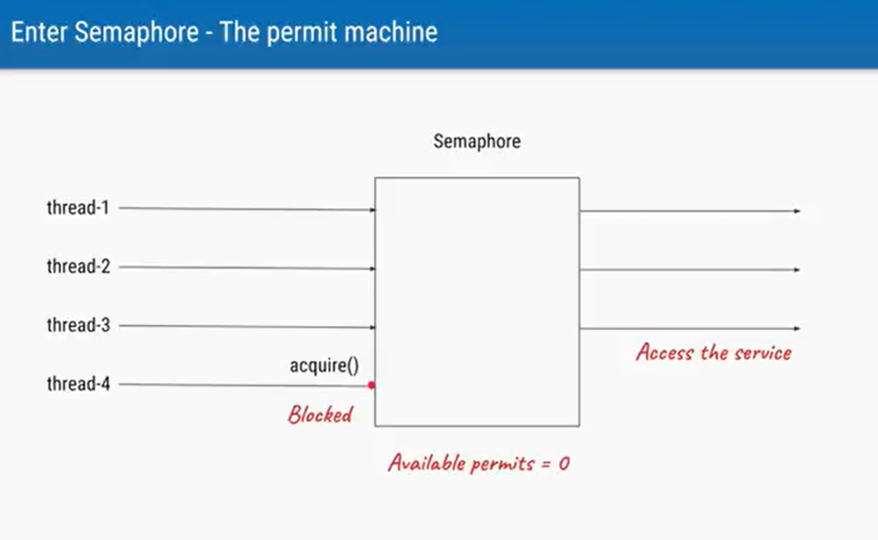

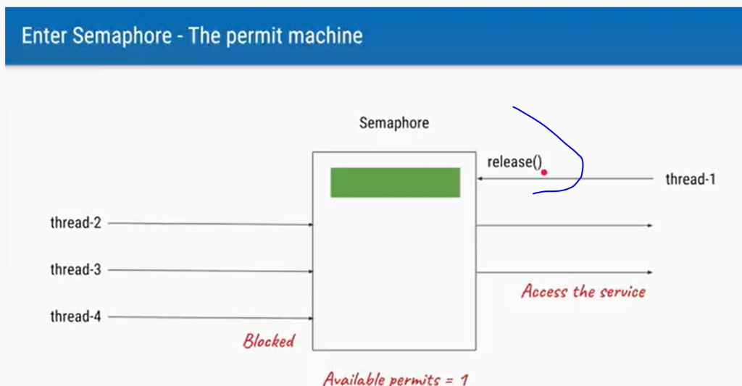

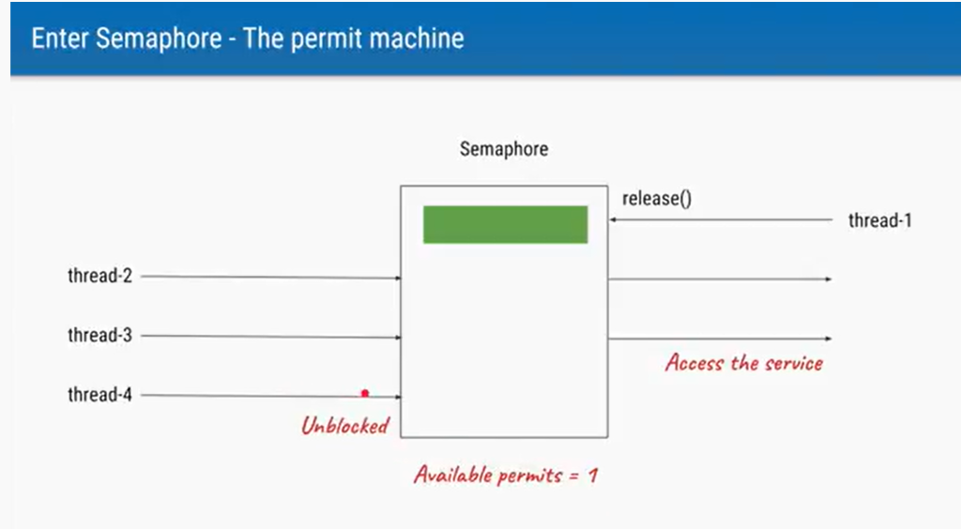

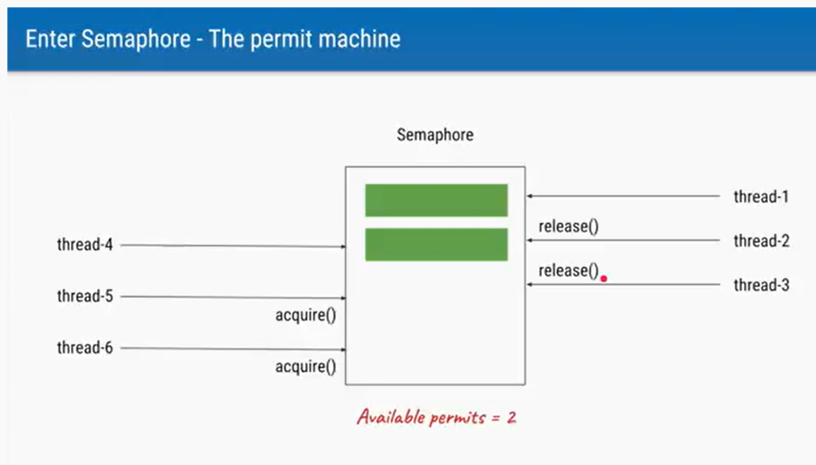

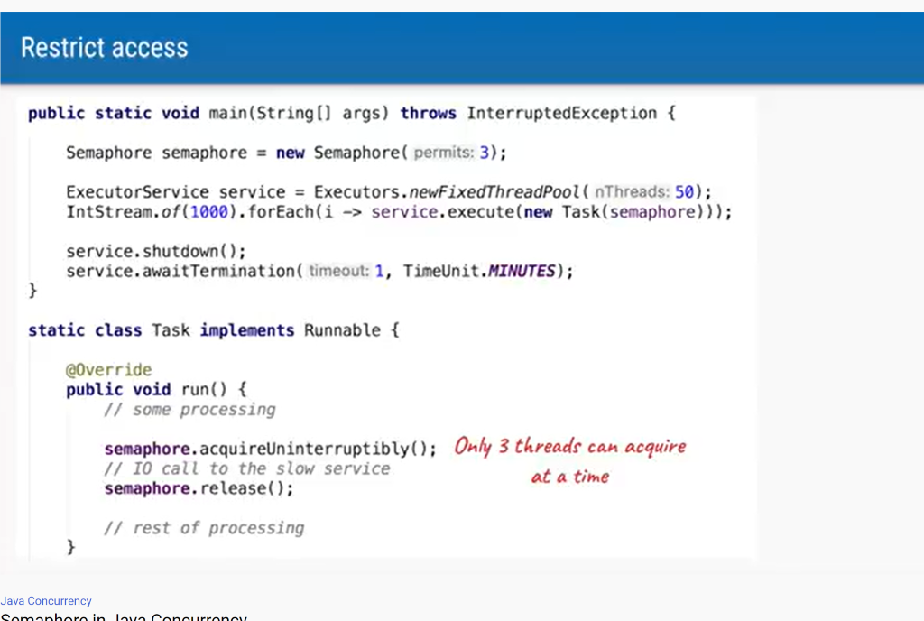

A counting semaphore. Conceptually, a semaphore maintains a set of permits. Each [acquire()](https://docs.oracle.com/javase/7/docs/api/java/util/concurrent/Semaphore.html#acquire()) blocks if necessary until a permit is available, and then takes it. Each [release()](https://docs.oracle.com/javase/7/docs/api/java/util/concurrent/Semaphore.html#release()) adds a permit, potentially releasing a blocking acquirer. However, no actual permit objects are used; the Semaphore just keeps a count of the number available and acts accordingly.

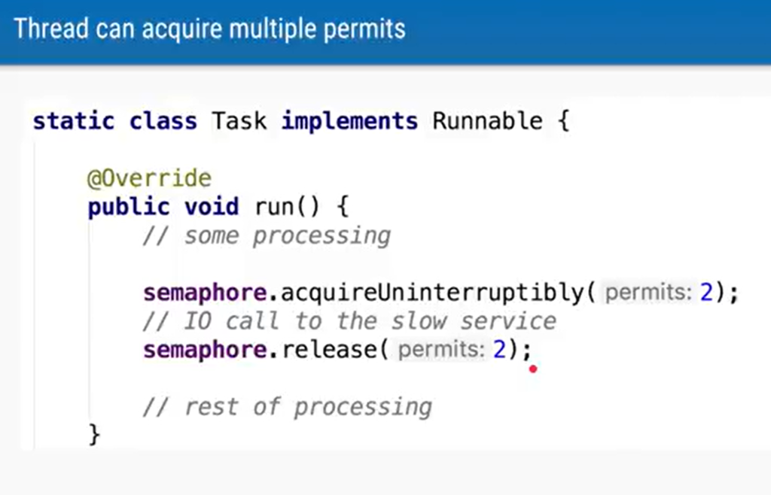

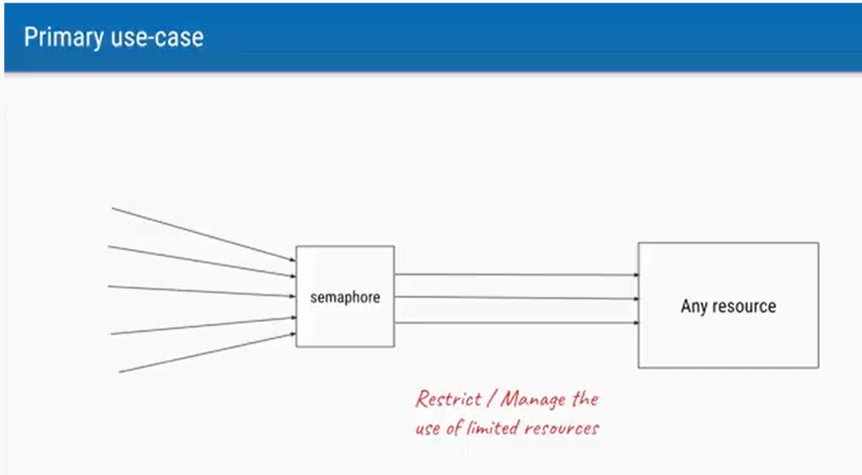

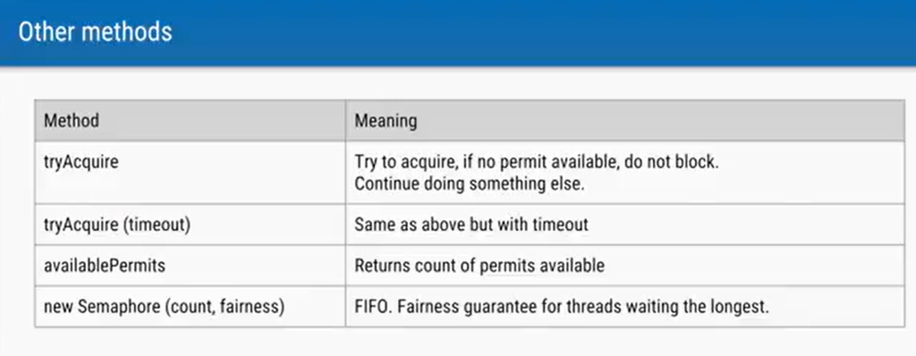

17 – Java concurrency interview question



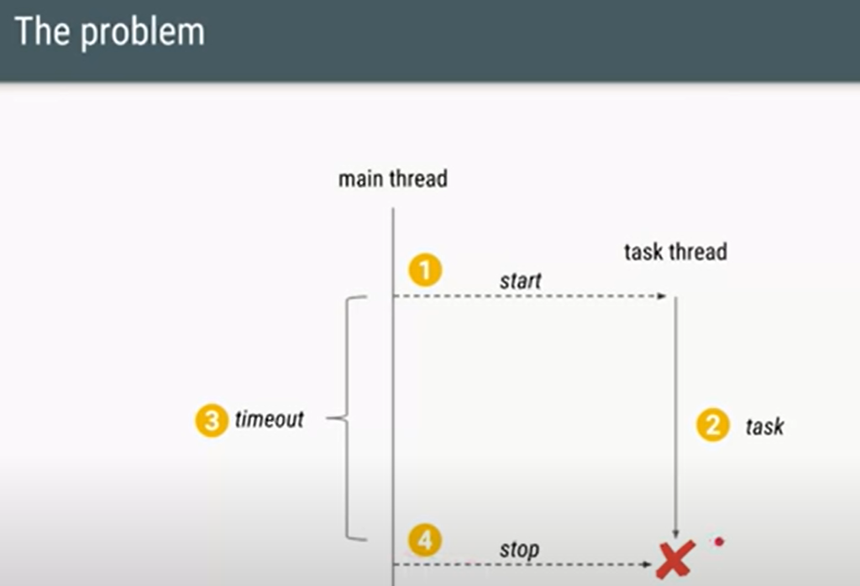

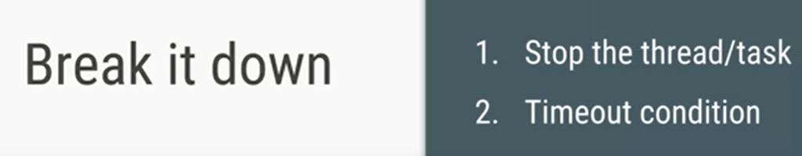



Note

: we do not have stop method in thread class

First approach

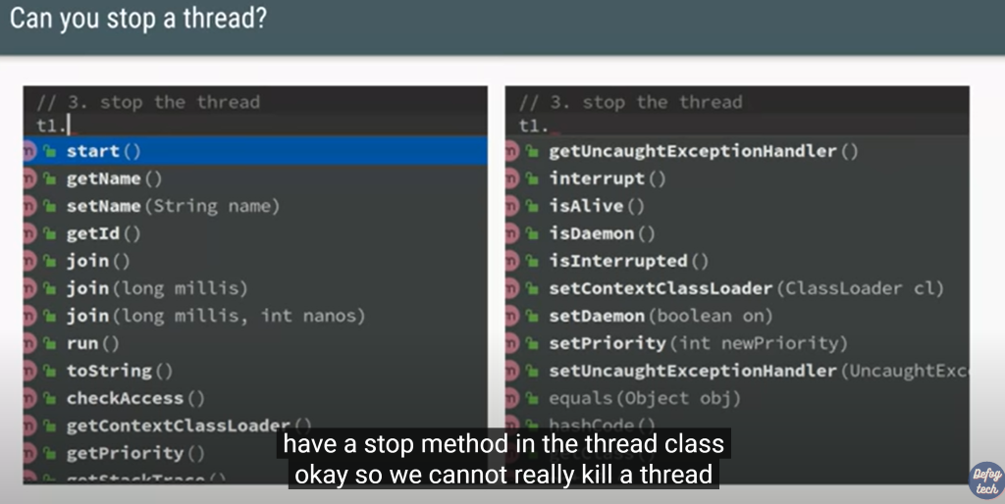

**Second approach**

For threadpool we can do shutdown

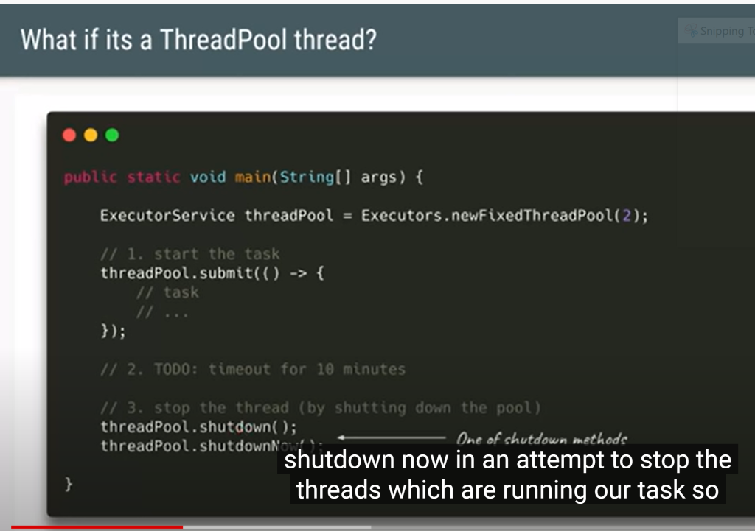

Using even a threadpool it will not solve the problem

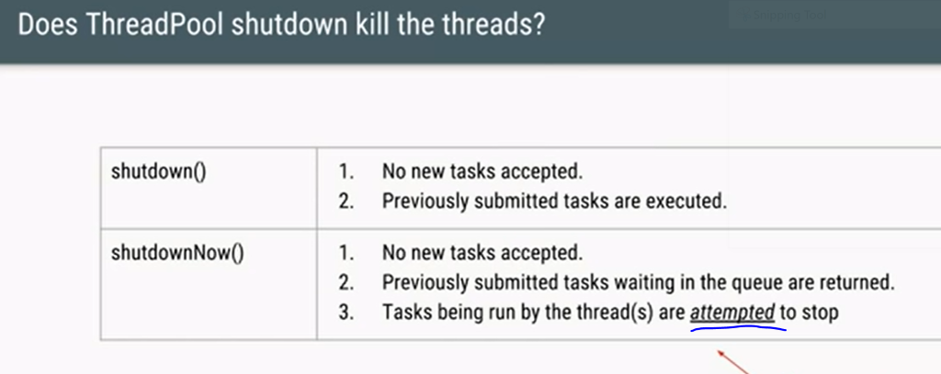

**Third approach**

Here also it does not make sure that it will stop the thread. It will only attempt to stop the thread

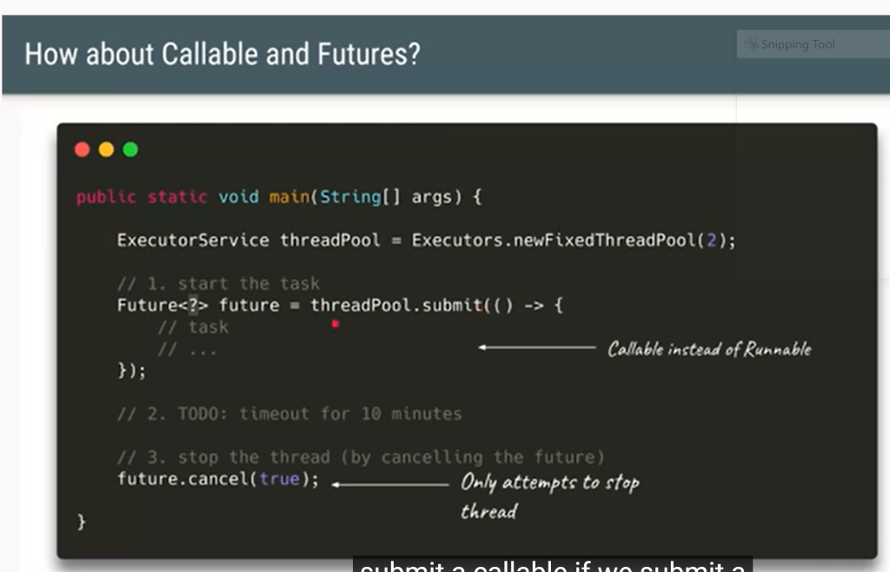





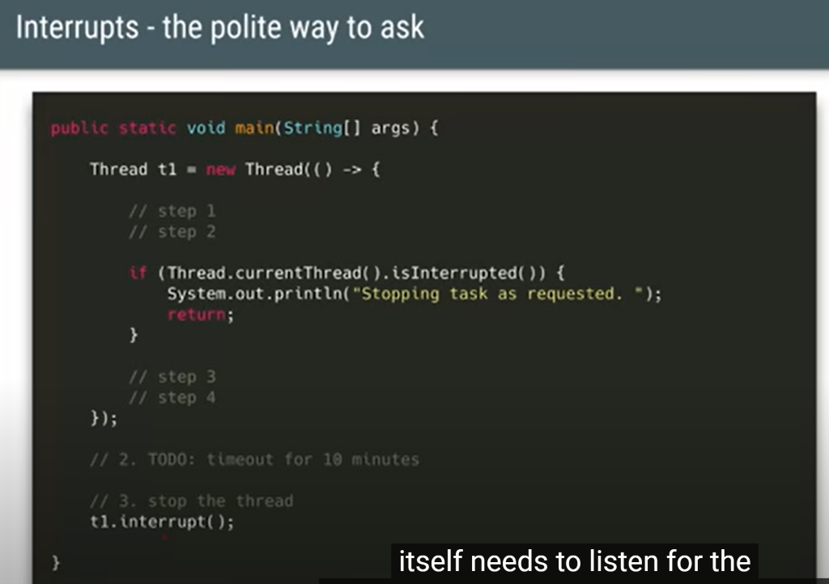

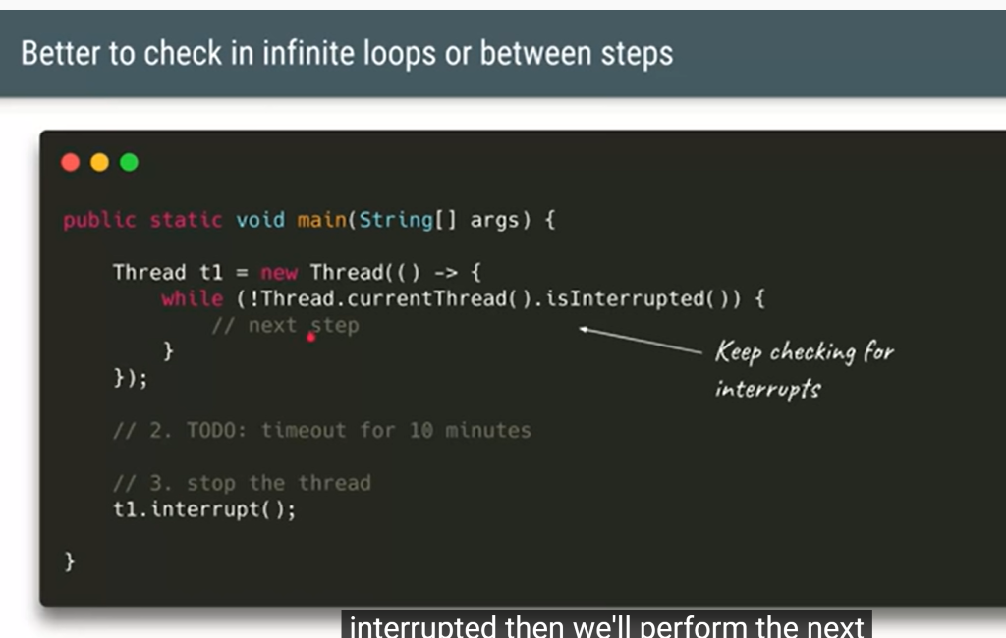

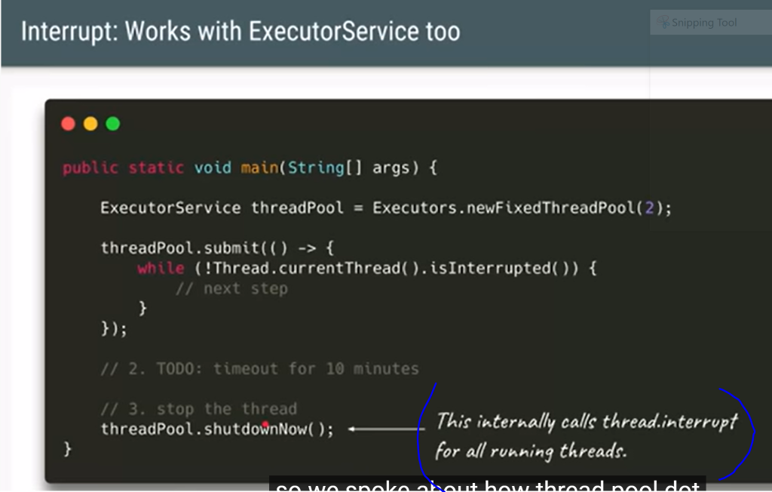

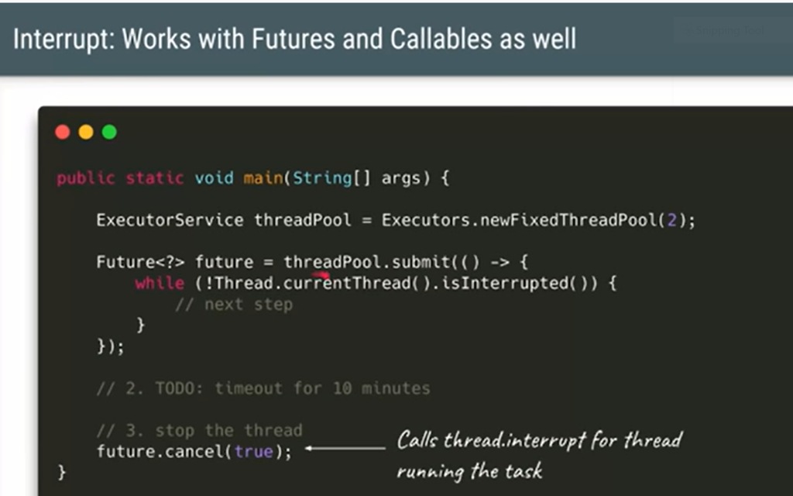

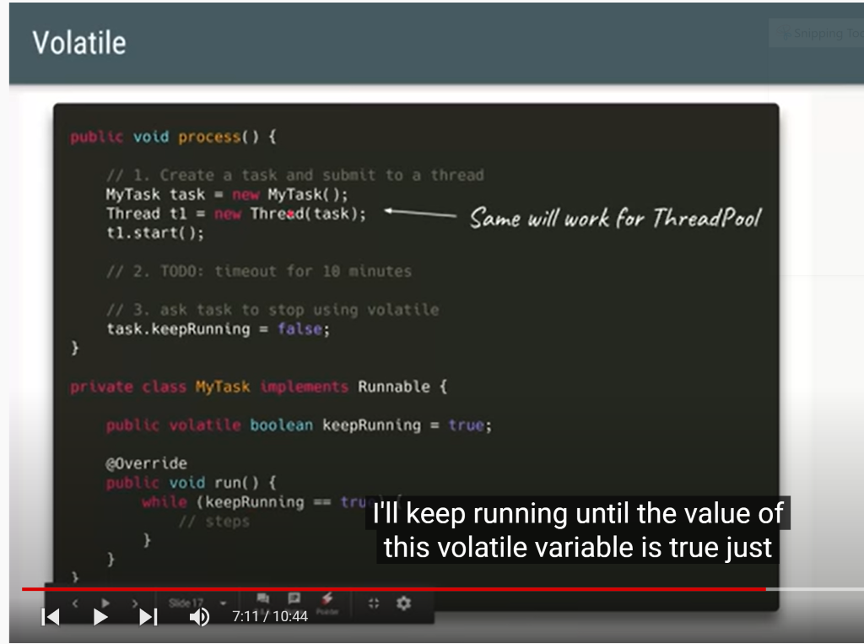

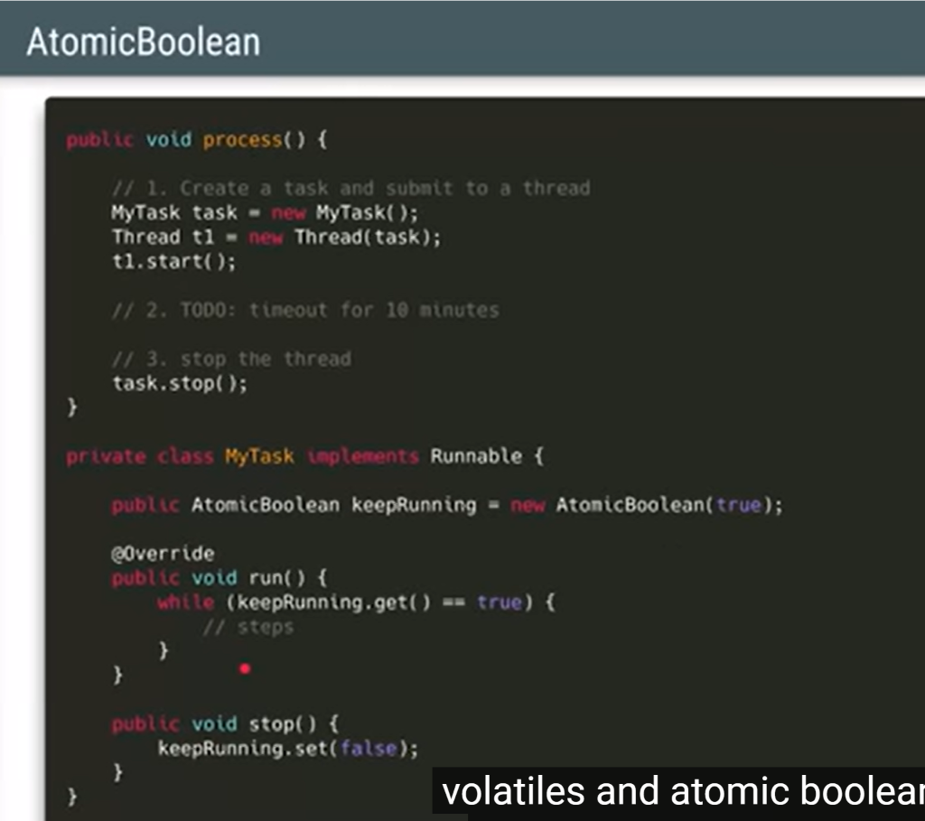

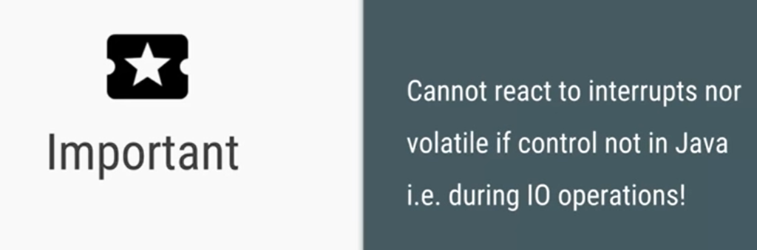

It imp to confirm that is not a io operation

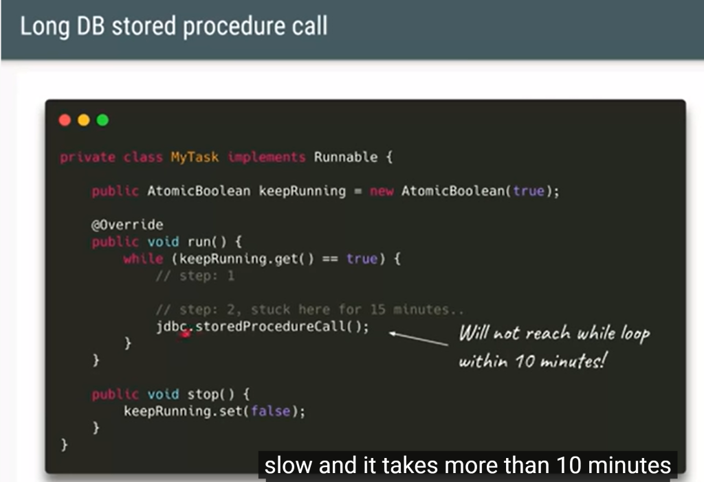



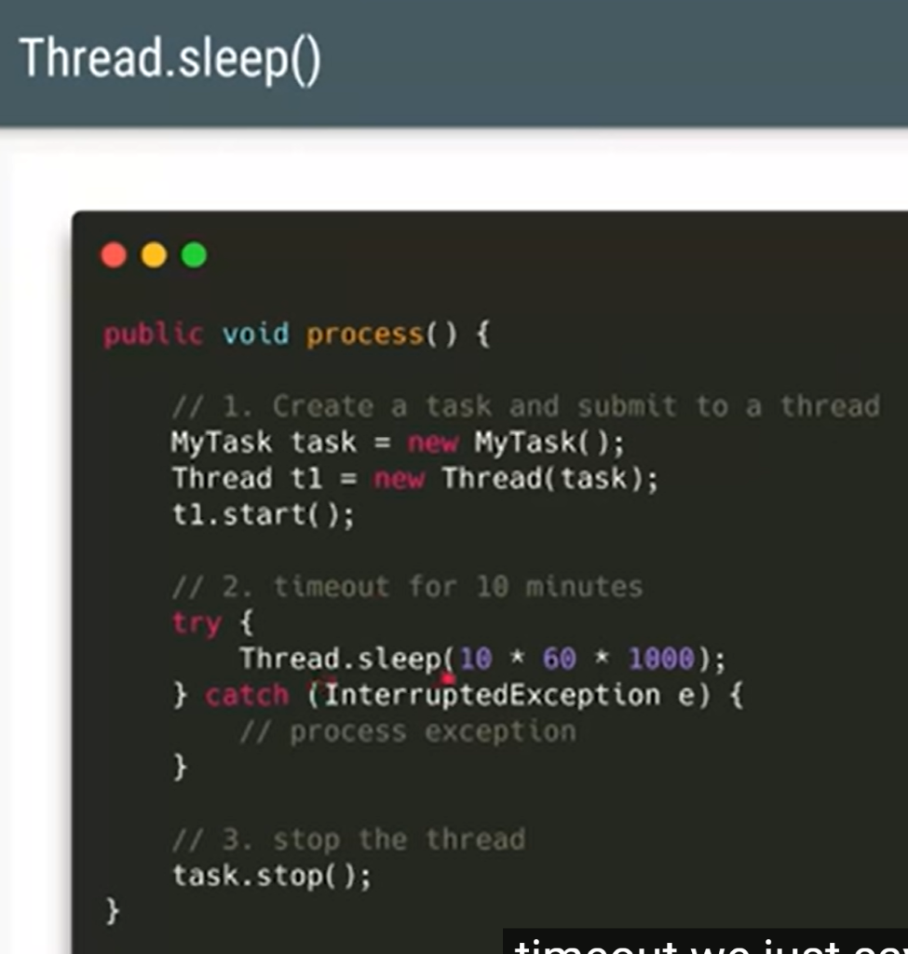

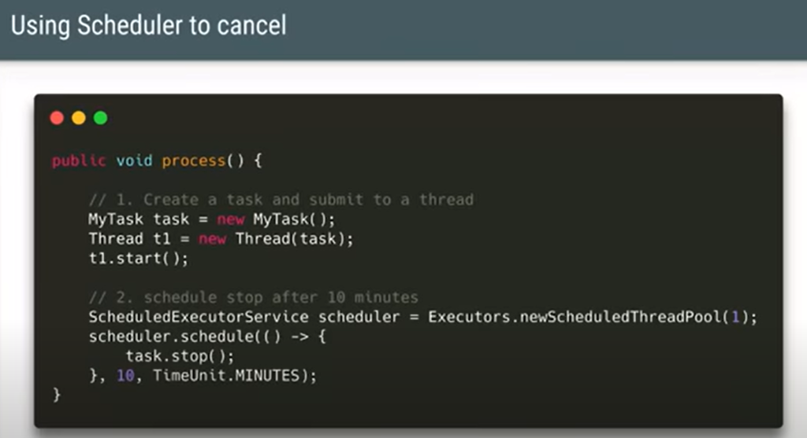

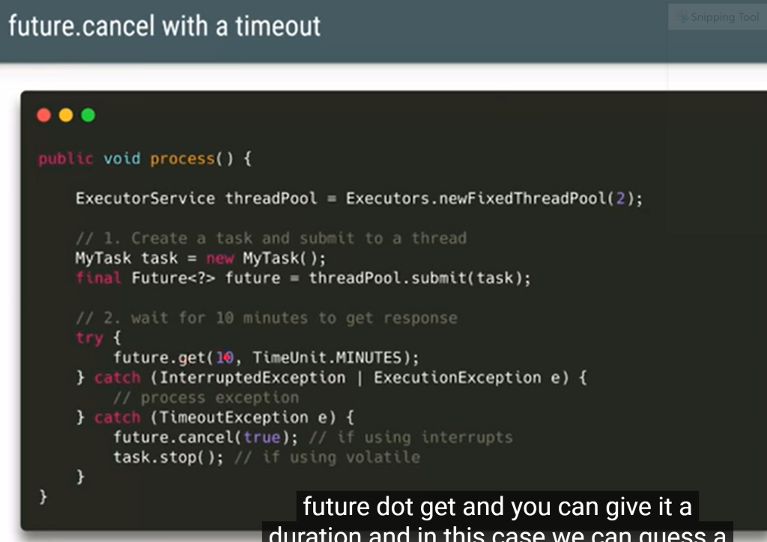

18 : Implement producer and consumer problem

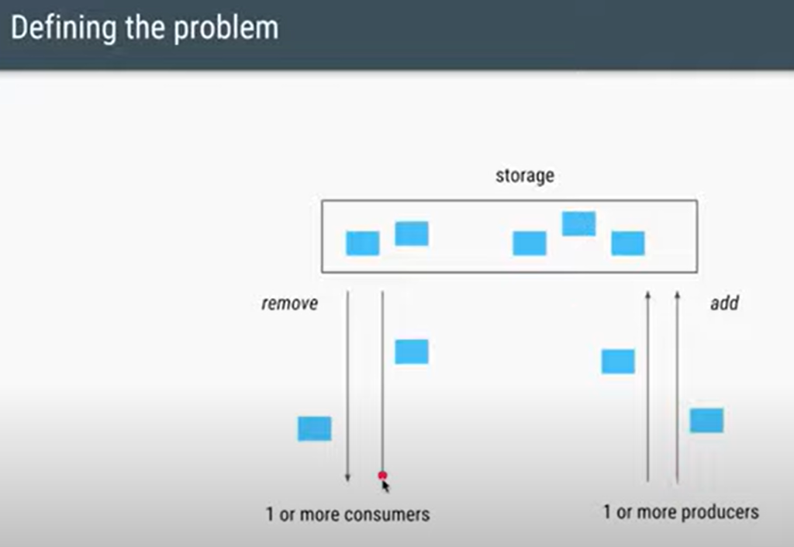

If there is no item in storage consumer have to wait

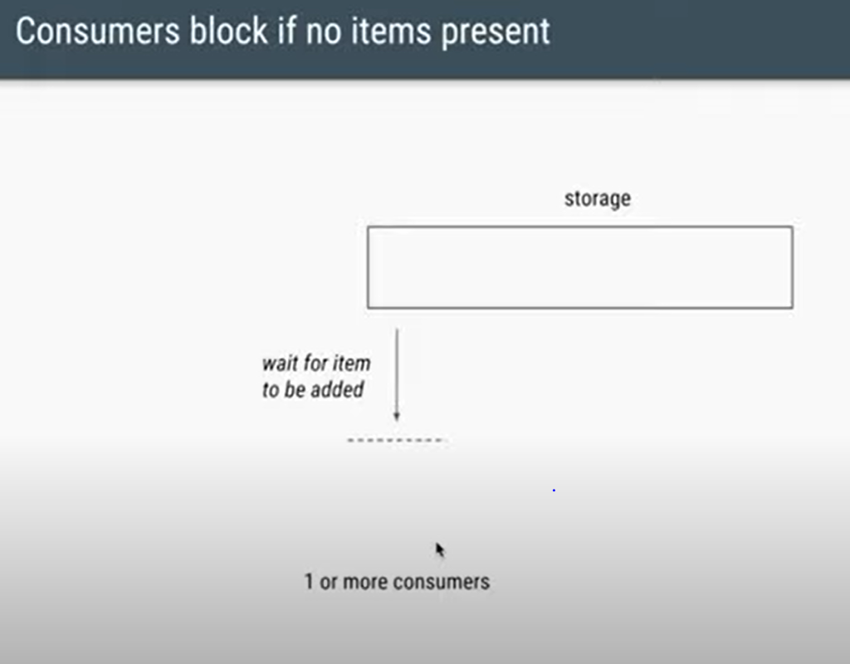

When producer add item in storage then consumer can proceed

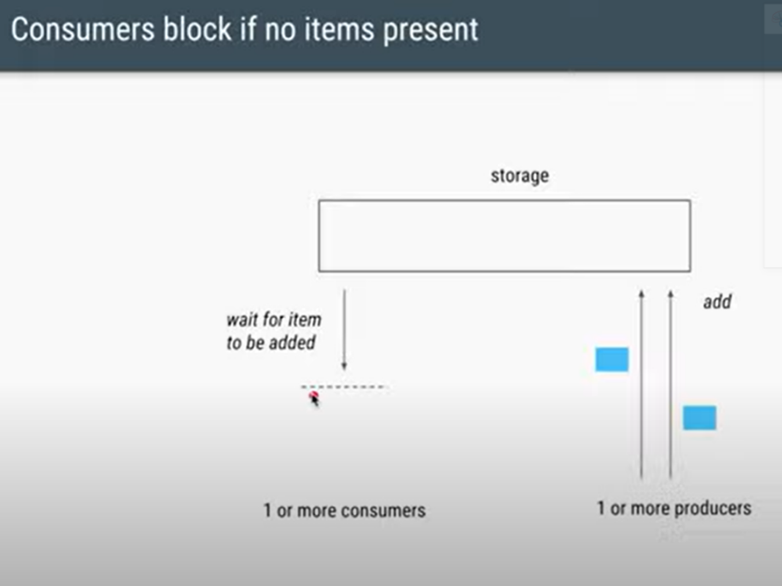

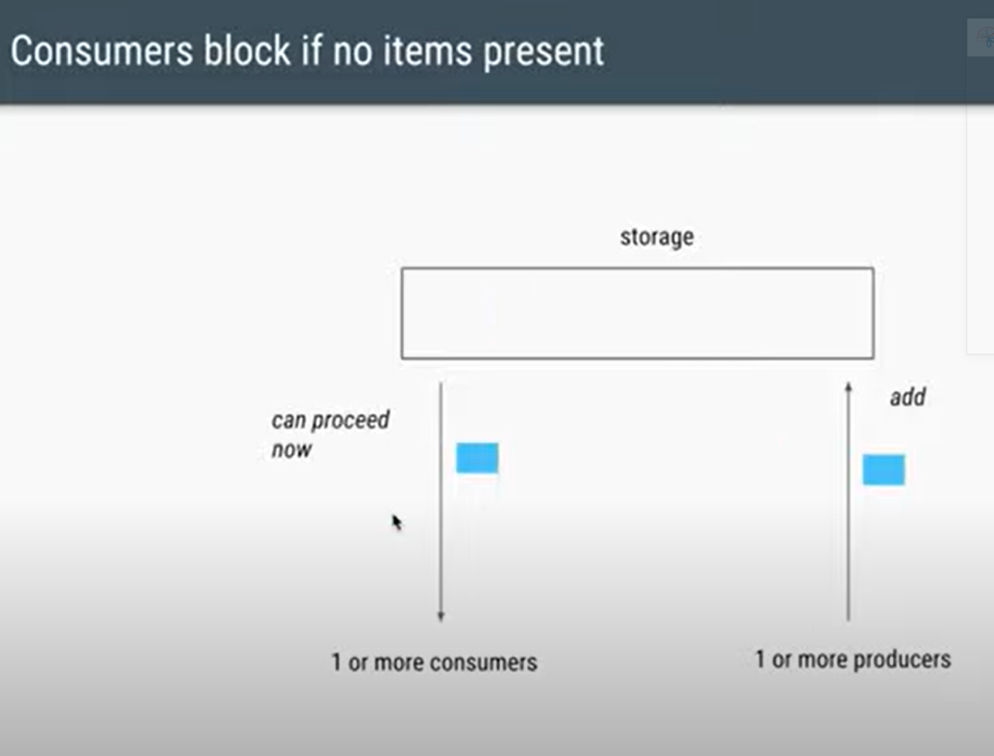

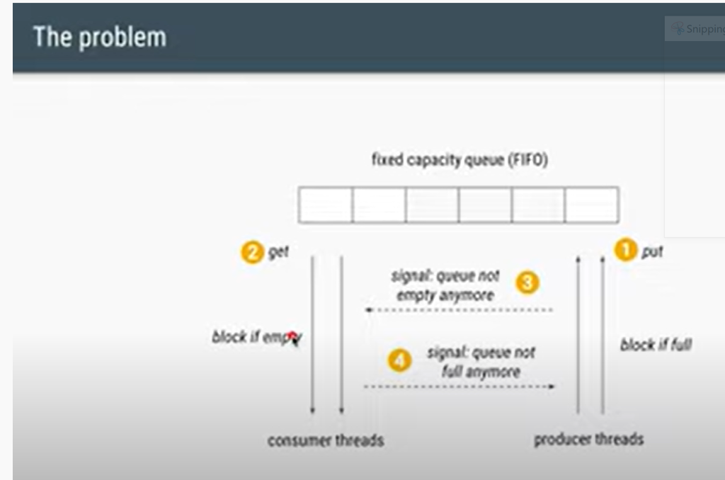

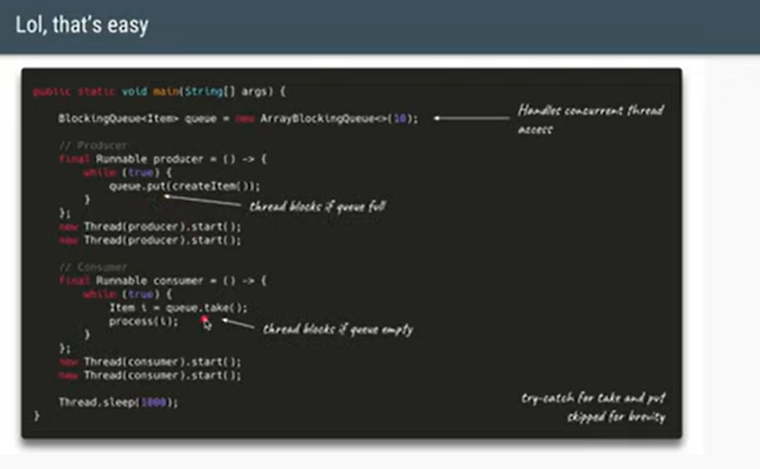

19 :  Implement Scatter Gather Pattern